MATHEMATICS STAGE 3
TEACHING AND LEARNING OVERVIEW
TERM: | WEEK: | STRAND: Measurement & Geometry | SUB-STRAND: 2D Space 1 | WORKING MATHEMATICALLY:  MA3-1WM & MA3-2WM
OUTCOMES: MA3-15MG |  | Manipulates, classifies and draws two-dimensional shapes, including equilateral, isosceles and scalene triangles, and describes their properties.
CONTENT: |  | Describe translations, reflections and rotations of two-dimensional shapes  - Identify and quantify the total number of lines (axes) of symmetry (if any exist) of two-dimensional shapes,  including the special quadrilaterals and triangles  - Identify shapes that have rotational symmetry and determine the 'order' of rotational symmetry  - Construct designs with rotational symmetry, with and without the use of digital technologies
ASSESSMENT FOR LEARNING  (PRE-ASSESSMENT) |  | Pre-Assessment - Draw in the Lines of Symmetry: Refer to embedded document on the left.  Barrier Game: In pairs, students are positioned back to back. One student is the ‘sketcher,’ the other student is the ‘describer’. The ‘describer’ describes a shape that has 1 or more lines of symmetry. The ‘sketcher’ listens to the description and sketches the 2D shape described. The ‘sketcher’ names the 2D shape sketched and draws in the correct number of lines of symmetry.
WARM UP / DRILL |  | Roboid Game – Symmetry Mission 2: Students progress through the game by identifying 2D shapes and their lines of symmetry.  http://www.bbc.co.uk/bitesize/ks2/maths/shape_space/symmetry/play/popup.shtml
TENS ACTIVITY  NEWMAN’S PROBLEM  INVESTIGATION |  | James wrote a capital letter that matched itself more than once on a complete rotation. What might the letter be?  How many other capital letters match themselves more than once on a complete rotation?
QUALITY TEACHING ELEMENTS |  | INTELLECTUAL QUALITY | QUALITY LEARNING ENVIRONMENT | SIGNIFICANCE
 |  | - Deep knowledge  - Deep understanding  - Problematic knowledge  - Higher-order thinking  - Metalanguage  - Substantive communication | - Explicit quality criteria  - Engagement  - High expectations  - Social support  - Students’ self-regulation  - Student direction | - Background knowledge  - Cultural knowledge  - Knowledge integration  - Inclusivity  - Connectedness  - Narrative
RESOURCES |  | Paper, cardboard, scissors, pencil, split pins, Microsoft Word and Internet access

TEACHING AND LEARNING EXPERIENCES
WHOLE CLASS INSTRUCTION MODELLED ACTIVITIES | GUIDED & INDEPENDENT ACTIVITIES
- Explicitly communicate lesson outcomes and work quality.  - Define and Reinforce metalanguage used in the unit; shape, two-dimensional shape (2D shape), triangle, equilateral triangle, isosceles triangle, scalene triangle, right angled triangle, quadrilateral, parallelogram, rectangle, rhombus, square, trapezium, kite, pentagon, hexagon, octagon, regular shape, irregular shape, features, properties, side, parallel, pair of parallel sides, opposite, length, vertex (vertices), angle, right angle, line (axis) of symmetry, rotational symmetry, order of rotational symmetry, translate, reflect, rotate and enlarge.  - Demonstration: Teacher demonstrates how to identify and quantify the total number of lines (axes) of symmetry (if any exist) of 2D shapes, including the special quadrilaterals and triangles.  http://www.innovationslearning.co.uk/subjects/maths/activities/year3/symmetry/shape_game.asp  http://www.bbc.co.uk/bitesize/ks3/maths/shape_space/symmetry/activity/ | LEARNING SEQUENCE  Remediation  S2 or Early S3 | - Paper cutting: Students fold Brennex squares and cut patterns to create symmetrical shapes.  Additional activities can be found in the embedded document to the left.  - Flags: Students investigate and create flags which have symmetry.  Please refer to embedded document to the left.  - Interactive Activity: Students investigate symmetry in the related interactive game at  http://www.fuelthebrain.com/Game/play.php?ID=302http://swgfl.skoool.co.uk/content/keystage3/maths/pc/learningsteps/SYMLC/launch.html
 | LEARNING SEQUENCE  S3  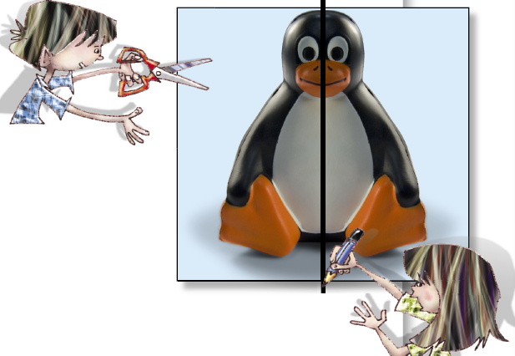 | - Magazine Picture Hunt: Students look for pictures in magazines that have symmetry.  Link to art lesson where students cut one of these images in half and replicate the opposing symmetrical side using media of choice or create butterflies using paint splodges.  - Symmetrical Designs: Students create symmetrical designs using 1, 2 and 4 lines of symmetry on grid paper as shown in diagram below.  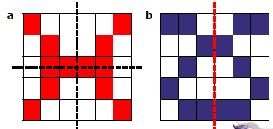  Examples  - Folding Task: Students explore lines of symmetry in a range of 2D shapes by folding cut-outs of various shapes.  - Photography: Students take photographs of symmetry in the natural environment and record their findings using computer technologies.
 | LEARNING SEQUENCE  Extension  Early S4 | - Tutorial: Students investigate rotational symmetry at  http://www.eduplace.com/cgi bin/schtemplate.cgi?template=/kids/mw/help/eh_popup.thtml&grade=5&chapter=15&lesson=9&title=Symmetry&tm=tmff1509e\  - Interactive Tool: Students investigate axial symmetry (vertical, horizontal and diagonal) at  http://swgfl.skoool.co.uk/content/keystage3/maths/pc/learningSimulations/ASXSC/launch.html
 | EVALUATION & REFLECTION | Student Engagement: Achievement of Outcomes:  Resources: Follow up:

TEACHING AND LEARNING EXPERIENCES
WHOLE CLASS INSTRUCTION MODELLED ACTIVITIES | GUIDED & INDEPENDENT ACTIVITIES
- Explicitly teach the concept of rotational symmetry. http://www.flashymaths.co.uk/swf/rsymmetry.swf  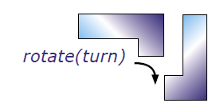  Student Extension Activity  Students mark all lines of symmetry on the 26 letters of the alphabet. They then colour the letters that have turn symmetry.  The alphabet letters are then categorised into the four groups below.  - Line symmetry only (12 letters)  - Line and turn symmetry (4 letters)  - Turn symmetry only ( 3 letters)  - No symmetry – (7 letters) | LEARNING SEQUENCE  Remediation  S2 or Early S3 | - Students view the interactive activity below to clarify the terms translation, rotation and reflection.  http://www.bbc.co.uk/bitesize/ks3/maths/shape_space/transformations1/activity/  - What does rotate mean? Students use body movement to rotate themselves 360 degrees in 90 degree increments e.g. Students find a point in the room and face a corner. Staying on the point, rotate for a quarter of a circle, or 90°.You should now face the next corner. Continue rotating to the next corner. You have rotated a half circle, or 180°.Continue rotating, until you face the corner where you started. You have rotated a full circle or 360°. Add additional relevant activities such as clockwise etc while playing “Simon Says”. Students who make incorrect rotations are out.  Play until there is a winner.
 | LEARNING SEQUENCE  S3  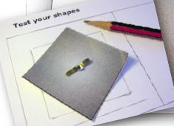  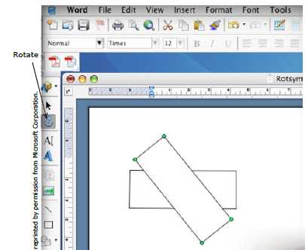 | Students identify shapes that have rotational symmetry and determine the 'order' of rotational symmetry.  - Students are given a variety of cardboard shapes to investigate their rotational symmetry by pinning each shape through the centre to grid paper and tracing the shapes onto the paper. While the cardboard shape remains still, students rotate the tracing around the pin. Students draw other shapes onto grid paper and predict whether they have rotational symmetry. They then check their predictions.  - Students construct a variety of designs with rotational symmetry using digital technologies. Open a Word document and bring up the drawing toolbar. Using AutoShapes, make a rectangle, or use the rectangle icon on the drawing toolbar. Repeat this with other shapes. Note: When using AutoShapes, pressing the shift key before drawing, and holding it down while drawing, forces the shape to be regular. For example, using the shift key will force a rectangle to be a square, an oval to be a circle, a triangle to be equilateral, a pentagon to be regular etc. Repeat using other shapes. Students make two columns; one for shapes that match themselves more than once when rotated in a full circle and one for those that don’t. They then print out their Word document and email it to their teacher.  - Investigation: James wrote a capital letter that matched itself more than once on a complete rotation. What might the letter be? How many other capital letters match themselves more than once on a complete rotation. See alphabet sheet below.
 | LEARNING SEQUENCE  Extension  Early S4 | - Students play Rotation Mania using the file below.
 | EVALUATION & REFLECTION | Student Engagement: Achievement of Outcomes:  Resources: Follow up:

