MATHEMATICS STAGE 3
TEACHING AND LEARNING OVERVIEW
TERM: | WEEK: | STRAND: Measurement & Geometry | SUB-STRAND: 2D Space 1 | WORKING MATHEMATICALLY:  MA3-1WM & MA3-2WM
OUTCOMES: MA3-15MG |  | Manipulates, classifies and draws two-dimensional shapes, including equilateral, isosceles and scalene triangles, and describes their properties.
CONTENT: |  | Describe translations, reflections and rotations of two-dimensional shapes.  - Use the terms 'translate', 'reflect' and 'rotate' to describe the movement of two-dimensional shapes  - Rotate a graphic or object through a specified angle about a particular point, including by using the rotate function in a computer drawing program  - Describe the effect when a two-dimensional shape is translated, reflected or rotated, eg when a vertical arrow is rotated 90°, the resulting arrow is horizontal  - Recognise that the properties of shapes do not change when shapes are translated, reflected or rotated
ASSESSMENT FOR LEARNING  (PRE-ASSESSMENT) |  | Pre-Assesssment: Graphic Representations: Students write definitions for the terms translation, reflection and rotation, draw 1-3 example(s) of each and share their understanding of these transformations with the class. These definitions are then checked using the Online Maths Dictionary: http://www.amathsdictionaryforkids.com/dictionary.html  Students then design posters to display these transformations, which are then used to guide and direct further learning.
WARM UP / DRILL |  | Mirror-Mirror: Using body movements, students mirror their partners (reflect) replicate their position (slide) and turn in given directions (rotate) either left/ right or clockwise/anticlockwise.
TENS ACTIVITY  NEWMAN’S PROBLEM  INVESTIGATION |  | What 2D shapes have rotational symmetry?  What shape would be created if a square measuring 8cm x 8cm was joined with its reflection? Draw and label measurements.  What shapes would be created if a trapezium and its reflection were combined A vertically & B horizontally? Draw these shapes.
QUALITY TEACHING ELEMENTS |  | INTELLECTUAL QUALITY | QUALITY LEARNING ENVIRONMENT | SIGNIFICANCE
 |  | - Deep knowledge  - Deep understanding  - Problematic knowledge  - Higher-order thinking  - Metalanguage  - Substantive communication | - Explicit quality criteria  - Engagement  - High expectations  - Social support  - Students’ self-regulation  - Student direction | - Background knowledge  - Cultural knowledge  - Knowledge integration  - Inclusivity  - Connectedness  - Narrative
RESOURCES |  | Paper, cardboard, scissors, pencil, split pins, Microsoft Word, Internet access and interactive activities (as referenced)

TEACHING AND LEARNING EXPERIENCES
WHOLE CLASS INSTRUCTION MODELLED ACTIVITIES | GUIDED & INDEPENDENT ACTIVITIES
- Explicitly communicate lesson outcomes and expectations work quality.  - Review unit metalanguage as outlined on previous unit.  - Explicitly teach the concept and term of slide then introduce the term ‘translate.’ A translation (slide) is a movement in a straight line without rotation, reflection or change of size. e.g.  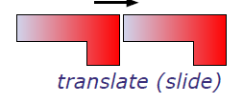  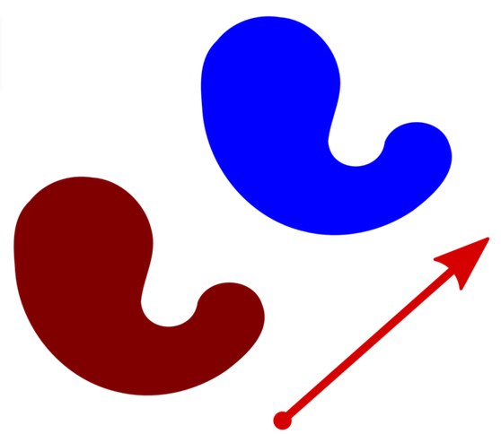  - Explicitly teach the concept and term reflection. A reflection (flip) is a mirror image of a shape. A shape has line symmetry if both its parts match exactly when folded.  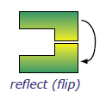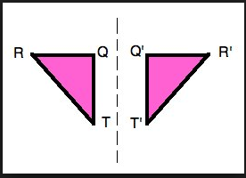 | LEARNING SEQUENCE  Remediation  S2 or Early S3 | - Revision Activities for Transformations: Students practise reflecting, translating and rotating shapes through the following interactive activities.  http://www.sheppardsoftware.com/mathgames/geometry/shapeshoot/TranslateShapesShoot.htm  http://www.harcourtschool.com/activity/icy_slides_flips_turns/  http://www.eduplace.com/kids/mw/swfs/robopacker_grade4.html
 | LEARNING SEQUENCE  S3 | - Treasure Map: Students translate and reflect plastic geometric shapes around a map of an island (with a 3cm x 3cm grid overlay) as directed by the teacher to locate a hidden treasure.  - The Transformation Game: Students follow given instructions to transform and draw shapes around a grid.  - Transformation Patterns: Students flip, slide or turn shapes and then trace around 2D shapes to create patterns. This activity can be repeated using reflections and rotations.  - IWB Transformations: Students transform shapes around a Cartesian plane as directed.  - Investigation: Download and use the shape overlays from TALE – SCOOTLE RESOURCES  The Shape overlays series of learning objects requires the student to manipulate 2D shapes by sliding and overlapping to create other 2D shapes. These include:  Shape Overlays: Picture Studio/ Shape Overlays: Find and Cut / Shape Overlays: Find, Cut and Turn /  Shape Overlays: Picture Puzzle
 | LEARNING SEQUENCE  Extension  Early S4 | - Interactive Axis of Symmetry Activity: Students explore the relationship between reflections and axis of symmetry using a Cartesian plane through the interactive game at https://www.mangahigh.com/en/games/transtar  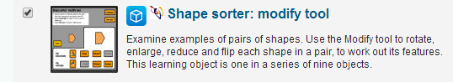  - Discriminating Shapes Interactive Activity: Shape Sorter ( Scootle resource - TALE log in required)  - Reflections Interactive activity: Students complete reflection activities at the site below.  http://www.transum.org/software/SW/Starter_of_the_day/Students/Transformations/Draw.asp
 | EVALUATION & REFLECTION | Student Engagement: Achievement of Outcomes:  Resources: Follow up:

