MATHEMATICS STAGE 3
TEACHING AND LEARNING OVERVIEW
TERM: | WEEK: 1 | STRAND: MEASUREMENT & GEOMETRY | SUB-STRAND: ANGLES 2 | WORKING MATHEMATICALLY:  MA3-1WM
OUTCOMES: MA3-16MG |  | Measures and constructs angles, and applies angle relationships to find unknown angles
CONTENT: |  | Investigate, with and without the use of digital technologies, angles on a straight line, angles at a point, and vertically opposite angles; use the results to find unknown angles  - identify and name angle types formed by the intersection of straight lines, including right angles, 'angles on a straight line', 'angles at a point' that form an angle of revolution, and 'vertically opposite angles'  - recognise right angles, angles on a straight line, and angles of revolution embedded in diagrams (Reasoning)  - identify the vertex and arms of angles formed by intersecting lines (Communicating)
ASSESSMENT FOR LEARNING  (PRE-ASSESSMENT) |  | - Have students complete a Frayer Model on angles.
WARM UP / DRILL |  | - I have, who has – Students use protractors to measure the angle on their card and write the measurement down. Students then play the game.  - YouTube – Types of Angles Seuss Song by Heath
TENS ACTIVITY  NEWMAN’S PROBLEM  INVESTIGATION |  | Lina learned about types of angles in geometry class. As she was walking home she looked at the letters on a street sign and noticed how many are made up of angles. The sign she looked at was KLINE ST. Which letter(s) on the sign have an obtuse angle? What other letters in the alphabet have an obtuse angle?
QUALITY TEACHING ELEMENTS |  | INTELLECTUAL QUALITY | QUALITY LEARNING ENVIRONMENT | SIGNIFICANCE
 |  | - Deep knowledge  - Deep understanding  - Problematic knowledge  - Higher-order thinking  - Metalanguage  - Substantive communication | - Explicit quality criteria  - Engagement  - High expectations  - Social support  - Students’ self-regulation  - Student direction | - Background knowledge  - Cultural knowledge  - Knowledge integration  - Inclusivity  - Connectedness  - Narrative
RESOURCES |  | Protractors – 1 per student, Protractor Power Point, cards displaying a variety of angles, worksheet, toothpicks, dot stickers, geometry bingo, Frayer model – angles, iPads.

TEACHING AND LEARNING EXPERIENCES
WHOLE CLASS INSTRUCTION MODELLED ACTIVITIES | GUIDED & INDEPENDENT ACTIVITIES
- Work through the Protractor PowerPoint with students, which will help them understand how to correctly use a protractor.  - Show students that a right angle can be in any orientation or rotation as long as the internal angle is 90⁰. Make a range of cards showing examples and non-examples or a right angle. Have students respond to each card by saying smaller, right angle, larger. Label the smaller and larger angles accordingly.  - Review the different types of angles, by working through the BBC Bitesize activity.  - List the different types of angles that were introduced through the BBC Bitesize tutorial. Brainstorm as a class where you might see or find these shapes. E.g. right angle – tissue box, piece of paper etc. | LEARNING SEQUENCE  Remediation  S2 or Early S3 | - iPad Photo Hunt: Using iPads (or cameras) students take photos of angles found in the school environment. Students classify them by the appropriate name.  - Toothpick Angles (modified): Students use paddle pop sticks or pipe cleaners to create right, acute, obtuse and straight angles.
 | LEARNING SEQUENCE  S3 | Whole Class Instruction and Modelled Activities  - Toothpick Angles: Students create and model different types of lines and angles, including parallel, perpendicular, intersecting, line segment, ray, acute, obtuse, right angle etc, using toothpicks and dot stickers.  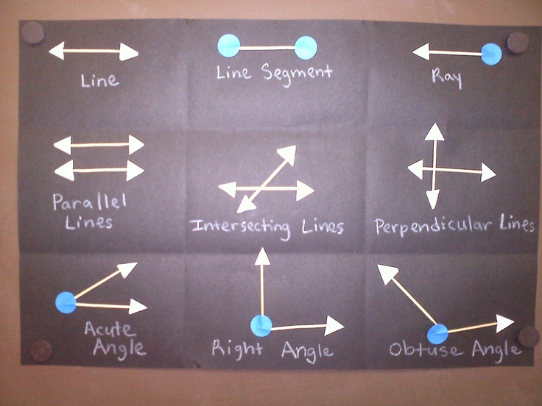  - Angles in the Environment: After discussing where we can see angles in the environment (modelled lesson 4) have students draw their own representation of items/things that represent these different angles.  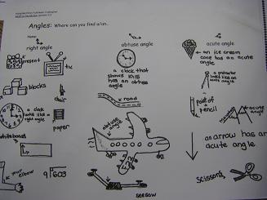  - Pirate Geometry Bingo: Play geometry bingo as a whole class. Students need to identify a range of angles and lines, including: obtuse angle, right angle, acute angle, straight angle, skew, ray, line, line segment etc. Game is available on Teachers Pay Teachers.  - Assessment: In pairs or small groups have students create their own video tutorial (similar to what can be found on YouTube) on how to identify the different types of angles.
 | LEARNING SEQUENCE  Extension  Early S4 | - Geometry Town Project: Students design a town map consisting of a range of angles and line patterns. An excellent project can be found on Teachers Pay Teachers – Geometry Town Project:: Using Geometric Vocabulary to Design a Map
 | EVALUATION & REFLECTION | Student engagement: Achievement of Outcomes:  Resources: Follow up:
- All assessment tasks should be written in red and planning should be based around developing the skills to complete that task.
- Assessment rubrics or marking scale should be considered.

Angles
Definition
Facts / Characteristics
Examples
Non-Examples

