MATHEMATICS STAGE 3
TEACHING AND LEARNING OVERVIEW
TERM: | WEEK: 2 | STRAND: MEASUREMENT & GEOMETRY | SUB-STRAND: ANGLES 2 | WORKING MATHEMATICALLY:  MA3-1WM
OUTCOMES: MA3-16MG |  | Measures and constructs angles, and applies angle relationships to find unknown angles
CONTENT: |  | Investigate, with and without the use of digital technologies, angles on a straight line, angles at a point, and vertically opposite angles; use the results to find unknown angles  - recognise vertically opposite angles in different orientations and embedded in diagrams (Reasoning)
ASSESSMENT FOR LEARNING  (PRE-ASSESSMENT) |  | - Ask students to draw, measure and label a range of angles including obtuse, acute and reflex in their workbooks or on a blank sheet of paper.  For this activity you should be assessing students’ ability to use a protractor correctly.
WARM UP / DRILL |  | - In pairs, students are positioned back to back. One student is the ‘sketcher’ and the other student is the ‘describer’. The ‘describer’ describes a given two-dimensional shape focussing on side and angle properties. The ‘sketcher’ listens to the description and sketches the two-dimensional shape described. The ‘sketcher’ names the two-dimensional shape sketched and then compares their sketch to the describer’s shape. The students swap roles and repeat the activity.
TENS ACTIVITY  NEWMAN’S PROBLEM  INVESTIGATION |  | - A water sprinkler covers 90 degrees of a backyard lawn. How many times will the sprinkler need to be moved in order to cover the full 360 degrees of lawn?
QUALITY TEACHING ELEMENTS |  | INTELLECTUAL QUALITY | QUALITY LEARNING ENVIRONMENT | SIGNIFICANCE
 |  | - Deep knowledge  - Deep understanding  - Problematic knowledge  - Higher-order thinking  - Metalanguage  - Substantive communication | - Explicit quality criteria  - Engagement  - High expectations  - Social support  - Students’ self-regulation  - Student direction | - Background knowledge  - Cultural knowledge  - Knowledge integration  - Inclusivity  - Connectedness  - Narrative
RESOURCES |  | Protractors – 1 per student, student workbooks, internet access, images which contain angles,

TEACHING AND LEARNING EXPERIENCES
WHOLE CLASS INSTRUCTION MODELLED ACTIVITIES | GUIDED & INDEPENDENT ACTIVITIES
- Review basic concepts around angles, pointing out that angles on a straight line total 180 degrees and angles surrounding a point total 360 degrees. Also review acute, right and obtuse angles.  - In student workbooks, have each student draw a straight line. Then ask them to draw another straight line that intersects with the first line. Ask students to colour in the all of the acute angles that they have formed in red and to colour in all the obtuse angles in blue. Ask students what they notice (the red and blue are both opposite each other). Inform students these angles are referred to as vertically opposite angles.  - Watch the following YouTube clip to further introduce vertically opposite angles (note: this clip contains no sound):  https://www.youtube.com/watch?v=XnbkAcbEnsg  - For further information on vertically opposite angles see:  http://www.mathsisfun.com/geometry/vertically-opposite-angles.html  As a class explore the following maths resource which allows the user to discover vertically opposite, corresponding, and alternate angles formed by parallel lines and a transversal through playing a game. There is also a video which demonstrates how angles are used when building bikes. http://www.learnalberta.ca/content/mejhm/index.html?l=0&ID1=AB.MATH.JR.SHAP&ID2=AB.MATH.JR.SHAP.ANG | LEARNING SEQUENCE  Remediation  S2 or Early S3 | - 2D Shapes and Angles: Provide students with a range of 2D shapes. Have them measure and label these angles using a protractor.  - What is my name worth: Students continue to explore basic angles. Students find the angles in their name – UPPERCASE LETTERS. See website for attachment http://www.uen.org/Lessonplan/preview.cgi?LPid=21520
 | LEARNING SEQUENCE  S3 | Whole Class Instruction and Modelled Activities  - Exploring vertical angles: Have students use the software available at http://www.mathwarehouse.com/geometry/angle/interactive-vertical-angles.php to manipulate and explore vertical angles.  - Drawing vertical angles: Once students understand the concepts and relationships supporting vertical angles have them draw a number of vertical lines and measure the angles using a protractor.  - Angles (adapted from curriculum support): Select an image that displays a variety of angles (including vertically opposite angles, adjacent angles and angles at a point). You could use an image of a familiar setting/place i.e. Luna Park, or have students take their own images at school, their community or home environment. Ask students what types of angles they can see on their image and ask them to draw the different types of angles that they can find. For instance, using the image below you could point out the Ferris wheel which is a great image to explore for vertically opposite angles, adjacent angles and angles at a point.  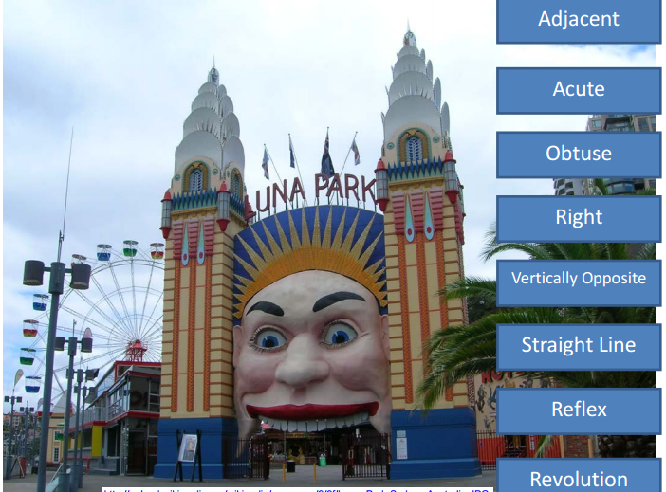  - Worksheets: There are a number of worksheets available in the link below to help support the concept of vertically opposite angles: https://wiki.gosford.spcc.nsw.edu.au/sandbox/groups/56creative/wiki/welcome/attachments/a849b/Y6%20Angles%20T1.pdf?sessionID=c44443f4ef0ad5b51ba12eb4b6b480ac63e0578b
 | LEARNING SEQUENCE  Extension  Early S4 | - Mini Golf Course: Students design their own mini-golf course. See this website for more details: http://www.australiancurriculumlessons.com.au/2012/11/26/angles-lesson-design-your-dream-mini-golf-course/
 | EVALUATION & REFLECTION | Student engagement: Achievement of Outcomes:  Resources: Follow up:
- All assessment tasks should be written in red and planning should be based around developing the skills to complete that task.
- Assessment rubrics or marking scale should be considered.

