MATHEMATICS STAGE 2
TEACHING AND LEARNING OVERVIEW
TERM: | WEEK: 6 | STRAND: Measurement and Geometry | SUB-STRAND: Area 2 | WORKING MATHEMATICALLY:  MA2-1WM & MA2-2WM
OUTCOMES: MA2-10MG |  | Measures, records, compares and estimates areas using square centimetres and square metres
CONTENT: |  | - Compare the areas of regular and irregular shapes by informal means.  - Develop strategies for counting partial units in the total area of the shape  - Measure the areas of irregular shapes using a square cm grid overlay.
ASSESSMENT FOR LEARNING  (PRE-ASSESSMENT) |  | - Students measure the same sized irregular shapes using a variety of smaller rectangular shapes.  - Discuss the results – Why is it important to use the same unit of measure?
WARM UP / DRILL |  | - Guess my number – Students choose a number and say higher or lower partner has to guess number. Fewest guesses wins. Multiplication shoot out. In teams they have a shoot out, quickest person stays in. Last person standing wins.

TENS ACTIVITY

NEWMAN’S PROBLEM

INVESTIGATION

QUALITY TEACHING ELEMENTS |  | INTELLECTUAL QUALITY | QUALITY LEARNING ENVIRONMENT | SIGNIFICANCE
 |  | ☑ Deep knowledge  ☑ Deep understanding  ☑ Problematic knowledge  ☑ Higher-order thinking  ☑ Metalanguage  - Substantive communication | ☑ Explicit quality criteria  ☑ Engagement  ☑ High expectations  ☑ Social support  ☑ Students’ self-regulation  - Student direction | ☑ Background knowledge  ☑ Cultural knowledge  ☑ Knowledge integration  ☑ Inclusivity  ☑ Connectedness  - Narrative
RESOURCES |  | Grid paper, transparent grid overlays, art paper, boxes, oranges, leaves  Nrich Maths – Torn Shapes  Area Teaching aid – How to calculate area?  Area Interactive Games

TEACHING AND LEARNING EXPERIENCES
WHOLE CLASS INSTRUCTION MODELLED ACTIVITIES | GUIDED & INDEPENDENT ACTIVITIES
- How do I know?  Provide students with a variety of cardboard irregular shapes and a sheet of grid paper. Have the students place the rectangles on top of the grid paper and use the grid structure to determine the total  number of units covered by the rectangle. Have students share their results with others and explain how they determined the total. Discuss with students why grid paper is useful for measuring.  Students will need to develop strategies for counting large numbers of square cms, Teacher will model and students complete  - marking off groups of ten and having a partner tally the tens  - covering a box or stone in grid paper and marking only the squares that can be seen.  - any square with more than half showing is counted as one  - any square with less than half showing is not counted or, alternatively, mark whole squares as1 and half squares as 0.5 | LEARNING SEQUENCE  Remediation  S1 or Early S2 | - Triangles  Cut a square with 4cm sides from centimetre grid paper. Find and record the area of this square. Draw in the diagonals and cut along them to form four triangles. Re-arrange the four triangles to make a rectangle. Find and record the area of the rectangle and discuss results with their group.  Nrich Maths – Torn Shapes  Area Teaching aid – How to calculate area?  Area Interactive Games
 | LEARNING SEQUENCE  S2 | Measure the areas of irregular shapes using a square-centimetre grid overlay,  e.g.  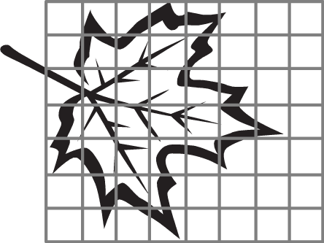  - Blobs  Make large paint blobs – students use square-centimetre grid overlay to work out the area. Students use strategies to deal with parts of a square cm.
 | LEARNING SEQUENCE  Extension  Late S2 or Early S3 | - Wrapping and Measuring  Students find surface areas of solids e.g. tennis ball, stone, box. Possible strategies include the following.  - Wrap the object in one centimetre grid paper and tick visible squares and colour partial squares.  - Flatten boxes and measure with transparent grid.  Investigation – Peel an orange and work out the area.
 | EVALUATION & REFLECTION | Student Engagement: Achievement of Outcomes:  Resources: Follow Up:

