MATHEMATICS EARLY STAGE 1
TEACHING AND LEARNING OVERVIEW
TERM: | WEEK:  2 and 3 | STRAND:  NUMBER AND ALGEBRA | SUB-STRAND:  ADDITION AND SUBTRACTION | WORKING MATHEMATICALLY:  MAe-1WM; MAe-2WM; MAe-3WM
OUTCOMES: MAe-5NA |  | Combines, separates and compares collections of objects, describes using everyday language, and records using informal methods
CONTENT: |  | Students:  - Use concrete materials or fingers to model and solve simple addition and subtraction problems  - Use visual representations of numbers to assist with addition and subtraction, eg ten frames  - Record addition and subtraction facts informally using drawings, words and numerals.  - Count forwards by ones to add, and backwards by ones to subtract  - Model subtraction by separating and taking away part of a group of objects
ASSESSMENT FOR LEARNING  (PRE-ASSESSMENT) |  | 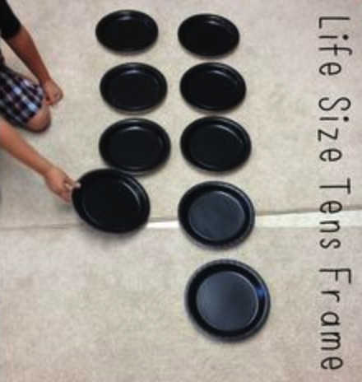  - Fives frames and tens frames: Students represent numbers to 10 using counters and personal tens frames, and identify how many are needed to complete the frame. Alternatively a whole class tens frame can be used by marking out the frame on the carpet and using plates as counters. Where one-to-one matching is not yet taking place students will begin this lesson sequence at the Pre-Foundation level to reinforce this counting skill.
WARM UP / DRILL |  | - Incidental opportunities during the school day to apply addition. Eg “there are three girls and two boys at this desk. How many students are at the desk all together?”  - Using tens frames flash cards (concrete or generated on the IWB). Children subitise and call out the number of dots. Extension drill would have students calling out the number of dots needed to make 10.
TENS ACTIVITY  NEWMAN’S PROBLEM  INVESTIGATION |  | TENS activity covered as part of guided and independent activities as EAS is being addressed in this strand.
QUALITY TEACHING ELEMENTS |  | INTELLECTUAL QUALITY | QUALITY LEARNING ENVIRONMENT | SIGNIFICANCE
 |  | - Deep knowledge  - Deep understanding  - Problematic knowledge  - Higher-order thinking  - Metalanguage  - Substantive communication | - Explicit quality criteria  - Engagement  - High expectations  - Social support  - Students’ self-regulation  - Student direction | - Background knowledge  - Cultural knowledge  - Knowledge integration  - Inclusivity  - Connectedness  - Narrative
RESOURCES |  | Tens frames flashcards, Counters, tens frames, fives frames, egg cartons, unifix cubes, double-sided counters, plates

TEACHING AND LEARNING EXPERIENCES
WHOLE CLASS INSTRUCTION MODELLED ACTIVITIES | GUIDED & INDEPENDENT ACTIVITIES
Students will be given real life opportunities to add two numbers together to make the whole.  - Similarly real life subtraction opportunities will also be part of class routines.  Egs  - “Our class has 12 girls today. Our class has 9 boys today. Today our class has 21 students”  - “Four children had apples for recess, and 6 children had bananas. Ten children had fruit for recess. “  - Students are shown how to represent these examples on the IWB using pictures, words and numbers. | LEARNING SEQUENCE  Pre Foundation Skills | - Emergent:  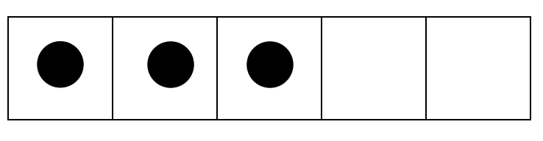  - Students count dots to 5 on a five frame to consolidate the understanding that one row of a tens frame is five. Students will subitise 1-5 on a five frame and use one to one matching to determine how many needed to make five.  “There are 3 dots. I need 2 more to make 5. “
 | LEARNING SEQUENCE  ES1 | - Perceptual:  - Students start to subitise rather than touching to count the number of dots on the tens frame.  - Investigation:  - Students use drawings, words and/or numbers to represent their investigation  - Students also recognise ten as a count by starting with ten counters on the frame and taking some away, stating how many are left on the frame.  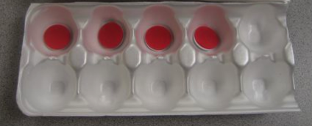  - Working in pairs one student represents numbers in tens frames made from egg cartons, using unifix cubes and their partner states how many more are needed to make ten.  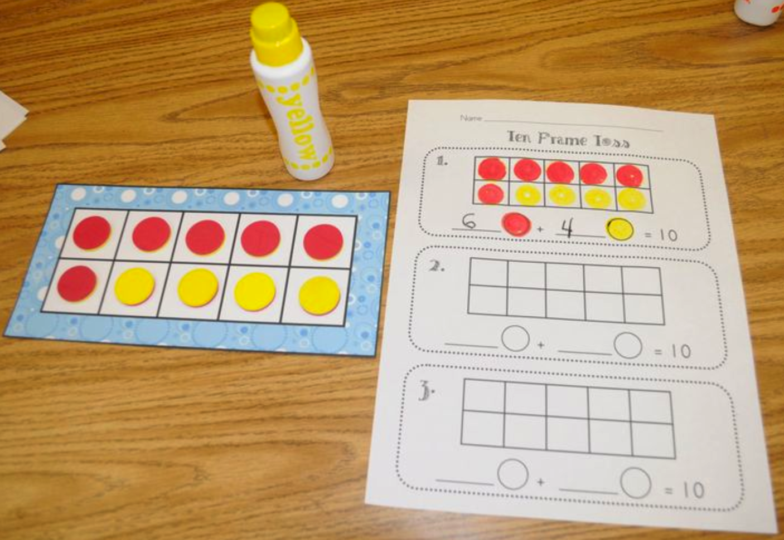  - Using 10 double-sided counters children shakes and scatters the counters and then uses the fall of counters (number of red and yellow counters) to determine numbers in the tens frame. Students then record the numbers represented and their sum using pictures and numerals. This can be completed as a small group activity or on a recording sheet as an assessment task.  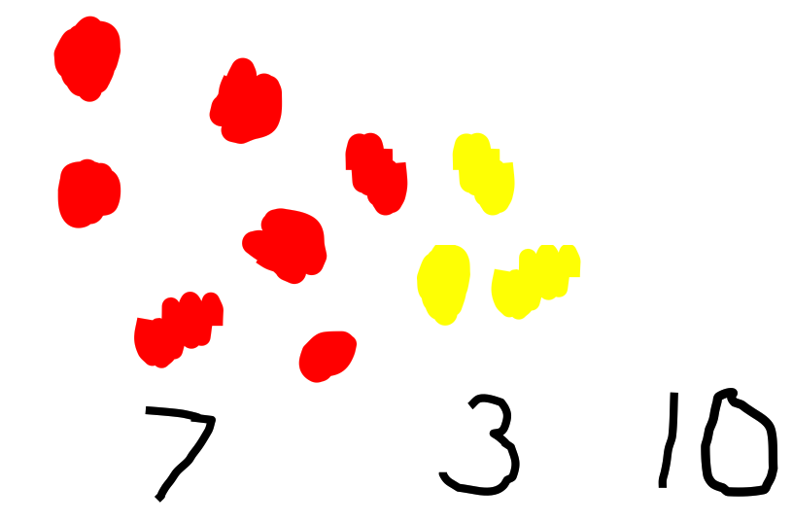  Step 1 Step 2 Step 3 Assessment Task  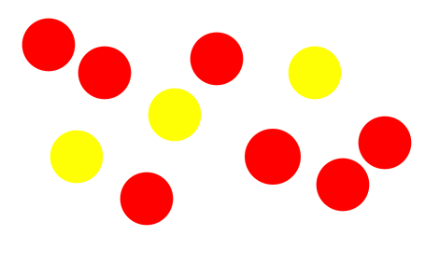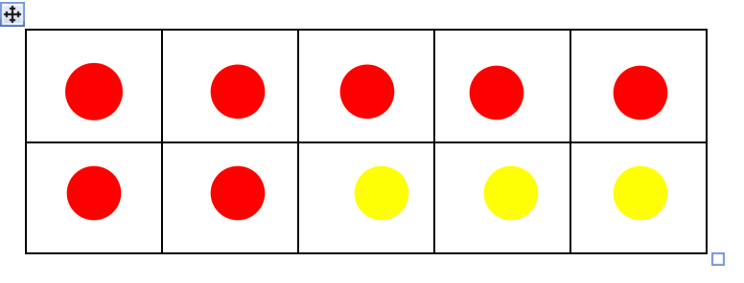
 | LEARNING SEQUENCE  Extension ES1  S1 | - Figurative:  - Introduce and model addition, subtraction and equals symbols. Students are given opportunities to apply these symbols in their representations of numbers on the tens frames.  - Further extension could include using two tens frames and modelling numbers to twenty.
 | EVALUATION & REFLECTION
- All assessment tasks should be written in red and planning should be based around developing the skills to complete that task.
TEACHING AND LEARNING EXPERIENCES
WHOLE CLASS INSTRUCTION MODELLED ACTIVITIES | GUIDED & INDEPENDENT ACTIVITIES
Students will be given real life opportunities to add two numbers together to make the whole.  - Similarly real life subtraction opportunities will also be part of class routines.  - Students are shown how to represent these examples on the IWB using pictures, words and numbers.  - The interrelatedness of addition and subtraction is modelled and explicitly taught using concrete materials such as unfix.  - “Blocks on a bowl” game modelled and taught. | LEARNING SEQUENCE  Pre Foundation Skills | - Emergent:  - Students join a number of unifix cubes starting with 5. Students are asked to create addition combinations using two colours, and attempt to represent these using words, numbers and pictures on white boards
 |  |  | Eg
 | LEARNING SEQUENCE  ES1 | - Perceptual:  Investigation:  - Students use concrete materials such as unifix cubes in two colours (as above) to model addition facts to 10. Students represent these number facts using words, numbers and pictures (White board can be photographed or representations recorded on a sheet to be retained for assessment folders).  - Students start with ten unifix cubes and remove some to model subtraction facts. Students represent these number facts using words numbers and pictures.  - “Blocks on a bowl” game using 10 unifix cubes: Working in pairs students take turns covering some of the blocks with a plastic bowl leaving the rest on top of the bowl. The other student predicts the number of blocks hidden.
 | LEARNING SEQUENCE  Extension ES1  S1 | Figurative:  - Introduction to place value: Students can model numbers beyond 10 and recognise ten as a count by representing tens with one colour of unifix and units with another.  - Addition and subtraction facts to 20 modelled using
 | EVALUATION & REFLECTION

