MATHEMATICS TEACHING AND LEARNING OVERVIEW STAGE 2

TERM: | WEEK: 1 | STRAND: Mass 1 | SUB-STRAND: Measurement and Geometry | WORKING MATHEMATICALLY:  MA2-1WM MA2-3WM
OUTCOMES: MA2 12MG |  | Measures, records, compares and estimates the masses of objects using kilograms and grams.
CONTENT: |  | Measure, order and compare objects using familiar metric units of mass (ACMMG061)  - use hefting to identify objects that have a mass of 'more than', 'less than' and 'about the same as' one kilogram  - discuss strategies used to estimate mass, eg by referring to a known mass (Communicating, Problem Solving)
ASSESSMENT FOR LEARNING  (PRE-ASSESSMENT) |  | - Students sit in a whole-class circle and pass around 4 or 5 closed containers that contain small items, to music. When the music stops, the students holding the containers write on the board their estimate of the mass of the container and its contents as being: less than 1kg, about 1kg or more than 1kg. After several estimates for the different objects have been recorded, teacher weighs the items to determine who had the closest estimate.

WARM UP / DRILL
TENS ACTIVITY  NEWMAN’S PROBLEM  INVESTIGATION |  | What’s My Weight (see worksheet)
QUALITY TEACHING ELEMENTS |  | INTELLECTUAL QUALITY | QUALITY LEARNING ENVIRONMENT | SIGNIFICANCE
 |  | - Deep knowledge  - Deep understanding  - Problematic knowledge  - Higher-order thinking  - Metalanguage  - Substantive communication | - Explicit quality criteria  - Engagement  - High expectations  - Social support  - Students’ self-regulation  - Student direction | - Background knowledge  - Cultural knowledge  - Knowledge integration  - Inclusivity  - Connectedness  - Narrative
RESOURCES |  | 4-5 closed containers with different amounts of plasticine in them  1 1kg weight per group  sand, marbles, blocks, paddle-pop sticks, large books (like encyclopaedias, dictionaries) various heavy and light items that can be hefted.

TEACHING AND LEARNING EXPERIENCES
WHOLE CLASS INSTRUCTION MODELLED ACTIVITIES | GUIDED & INDEPENDENT ACTIVITIES
Organise students into groups and provide each group with a kilogram weight. Students heft the weight to support their concept of a mass of 1 kilogram. List objects that it would be appropriate to be sold in 1kg packaging.  - Problem: You have 1kg packet of rice and more than 1kg of flour. You need to measure out 1kg of flour. (Hefting rice). Discuss  - Challenge: Students heft one tennis ball and a 1kg weight to try to estimate how many tennis balls in 1kg. (Apples, oranges, class novels, etc) | LEARNING SEQUENCE  Remediation  S1 or Early S2
 | LEARNING SEQUENCE  S2 | - Students heft their pencil cases (including contents), and sort the cases from lightest to heaviest. Students discuss which pencil cases would make a combined mass of about 1 kilogram. Weigh the predicted combinations and record the results stating if the mass of the pencil cases was less than 1 kilogram, equal to 1 kilogram or more than 1 kilogram.  - In groups, students are provided sand, rice, marbles, blocks, (any appropriate items) and large plastic containers. Students estimate 1kg by hefting a weight.  - Language Use – hefting (not weighing), What is the mass? More, less, how much, kilogram (avoid K-Gs) kilos,
 | LEARNING SEQUENCE  Extension  Late S2 or Early S3 | The stations may be taken as whole class activities or they may be set up as activities that group students  - Make 50 grams  Students estimate how many of each object is needed to make a mass of 50 grams. Students select objects, record their estimate, then measure and record the actual number of objects needed to make a mass of 50 grams. Materials to weigh can include blocks, dice and counters from the classroom, as well as small food items such as peanuts or crackers, and household items including nails, bolts and batteries
 | EVALUATION & REFLECTION | Student Engagement: Achievement of Outcomes:  Resources: Follow Up:

What's My Weight?

This picture shows four equal weights on one side of the scale and an apple on the other side.

What can you say that is true about the apple and the weights?

If the apple weighs 180g , how heavy must one weight be?

If the apple weighed 375g , how heavy would one weight be?

If the apple was a giant one and weighed a full kilo and the weights were each 250g , what would the scale look like? How do you know? Can you prove it?

Money Measure
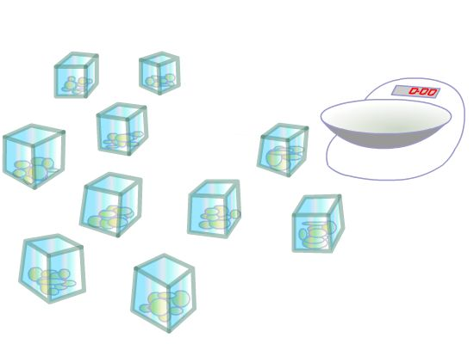
You have ten identical open-topped boxes with 10 visually identical coins in each.
In nine of the boxes each of the 10 coins has a mass of 10g.
In one box the 10 coins have masses of only 9g each.
How can you find which box is the odd one out?
You have a normal mass measurer with a single pan and a scale.
With just one weighing you can identify the box with the lighter coins.

What will you weigh?

Pies

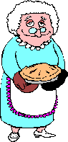
Stage: 2

Grandma had made pies for a bake sale. She had carefully put equal amounts of mixture in each pie tin and was now trying to find the weight of the pies.
She had a problem; she only had one 200 gram weight and one 125gram weight.
She found that one pie balanced on the scale with both weights and a quarter of a pie.
How heavy was each pie?

SOLUTIONS

What's My Weight?

From the picture of the scales, the apple must weigh less than the four weights altogether.
If the apple weighs 180g , for the scale to be balanced the weights would have to be 45g each because there are four of them. But we know from the picture that the apple weighs less than the weights put together, so each weight must be more than 45g .
If the apple weighed 375g , then for the scale to be balanced, each weight would be 93.75g . So, for the weights to be heavier than the apple, each one must be more than 375g .
One kilo is 1000g and four 250g weights would also weigh1000g altogether so the scale would be balanced.

Money Measure

Take one coin from the first box, two coins from the second box and so on. You will end up with 55 coins taken from the various boxes. Weigh the 55 coins. If the weight reads one gram less than 550 then 1 coin weighs 9 grams and box number 1 contains the light coins. If the weight reads 2 grams less than 550 then two coins weigh 9 grams and box number two contains the light coins and so on.

Pies
I got my answer of 433 1 3 grams by putting the problem into an equation. These are the steps I took to get the answer:
- First I did the sum 200g. + 125 g. which equalled325 g.
- Then I wrote it down like this: 325 g. + 1/4pie = pie
I then converted this to: 325 g. +1/4 pie =4/4pie (or one whole pie).
- Next, I took 1 4 of a pie from each side leaving me with: 325 g. = 3/4 pie.
- I multiplied each side by 4 which came out as: 1300 = 3 pies
- I divided each side by 3 and came to the final answer of:433 1/3grams = 1 pie."
Some Online Mass Sites
http://nrich.maths.org/4726
http://nrich.maths.org/public/leg.php?code=152

