MATHEMATICS TEACHING AND LEARNING OVERVIEW STAGE 2

TERM: | WEEK: 2 | STRAND: Mass 1 | SUB-STRAND: Measurement and Geometry | WORKING MATHEMATICALLY:  MA2-1WM MA2-3WM
OUTCOMES: MA2 12MG |  | Measures, records, compares and estimates the masses of objects using kilograms and grams.
CONTENT: |  | Measure, order and compare objects using familiar metric units of mass (ACMMG061)  - Use the kilogram as a unit to measure mass, using a pan balance  - recognise that objects with a mass of one kilogram can be a variety of shapes and sizes (Reasoning)  - associate kilogram measures with familiar objects, eg a standard pack of flour has a mass of 1 kg
ASSESSMENT FOR LEARNING  (PRE-ASSESSMENT) |  | - "Bigger is Heavier" (controversial statement).  - Students discuss statement. Show a golf ball and a tennis ball - which is heavier?  - Show a container filled with cotton balls and similar container filled with marbles: which would be heavier?
WARM UP / DRILL |  | - Using tally  - Counting by 5s, 10,
TENS ACTIVITY  NEWMAN’S PROBLEM  INVESTIGATION |  | Pies (see worksheet)
QUALITY TEACHING ELEMENTS |  | INTELLECTUAL QUALITY | QUALITY LEARNING ENVIRONMENT | SIGNIFICANCE
 |  | - Deep knowledge  - Deep understanding  - Problematic knowledge  - Higher-order thinking  - Metalanguage  - Substantive communication | - Explicit quality criteria  - Engagement  - High expectations  - Social support  - Students’ self-regulation  - Student direction | - Background knowledge  - Cultural knowledge  - Knowledge integration  - Inclusivity  - Connectedness  - Narrative
RESOURCES |  | Pan balances (one per group)  golf balls, tennis balls, rice, play dough  Class set of brochures or magazines

TEACHING AND LEARNING EXPERIENCES

WHOLE CLASS INSTRUCTION MODELLED ACTIVITIES | GUIDED & INDEPENDENT ACTIVITIES
Demonstrate how to weight 1kg of items using a pan balance.  Discuss common items are commonly packaged in 1kg packets.  - Cross – Curriculum – Students (pairs or small groups) make sculptures using exactly 1kg of plasticine or playdough. Discuss the different techniques and shapes. | LEARNING SEQUENCE  Remediation  S1 or Early S2
 | LEARNING SEQUENCE  S2 | Students make kilogram masses using a variety of materials e.g. marbles, tennis balls golf balls, textas, pairs of scissors (food items can also be used such as apples, oranges, muesli bars, snake lollies etc) Each group, does one item and reports back to class. Discuss differences in quantity of materials needed to make a kilogram  - Find pictures or draw pictures of items that are commonly packaged in 1kg packets.
 | LEARNING SEQUENCE  Extension  Late S2 or Early S3 | As Light as a Feather  Use kitchen scales and 10 gram weights to figure out the mass of very light objects. Ask the students to find objects in the class they think will weigh about 10 grams and compare these to the weights. They then weigh the object on the kitchen scales.
 | EVALUATION & REFLECTION | Student Engagement: Achievement of Outcomes:  Resources: Follow Up:
- All assessment tasks should be written in red and planning should be based around developing the skills to complete that task.
- Assessment rubrics or marking scale should be considered.

What's My Weight?

This picture shows four equal weights on one side of the scale and an apple on the other side.

What can you say that is true about the apple and the weights?

If the apple weighs 180g , how heavy must one weight be?

If the apple weighed 375g , how heavy would one weight be?

If the apple was a giant one and weighed a full kilo and the weights were each 250g , what would the scale look like? How do you know? Can you prove it?

Money Measure
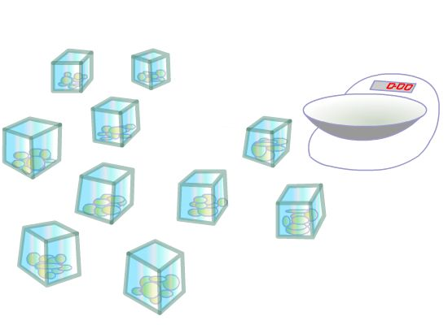
You have ten identical open-topped boxes with 10 visually identical coins in each.
In nine of the boxes each of the 10 coins has a mass of 10g.
In one box the 10 coins have masses of only 9g each.
How can you find which box is the odd one out?
You have a normal mass measurer with a single pan and a scale.
With just one weighing you can identify the box with the lighter coins.

What will you weigh?

Pies

Stage: 2

Grandma had made pies for a bake sale. She had carefully put equal amounts of mixture in each pie tin and was now trying to find the weight of the pies.
She had a problem; she only had one 200 gram weight and one 125gram weight.
She found that one pie balanced on the scale with both weights and a quarter of a pie.
How heavy was each pie?

SOLUTIONS

What's My Weight?

From the picture of the scales, the apple must weigh less than the four weights altogether.
If the apple weighs 180g , for the scale to be balanced the weights would have to be 45g each because there are four of them. But we know from the picture that the apple weighs less than the weights put together, so each weight must be more than 45g .
If the apple weighed 375g , then for the scale to be balanced, each weight would be 93.75g . So, for the weights to be heavier than the apple, each one must be more than 375g .
One kilo is 1000g and four 250g weights would also weigh1000g altogether so the scale would be balanced.

Money Measure

Take one coin from the first box, two coins from the second box and so on. You will end up with 55 coins taken from the various boxes. Weigh the 55 coins. If the weight reads one gram less than 550 then 1 coin weighs 9 grams and box number 1 contains the light coins. If the weight reads 2 grams less than 550 then two coins weigh 9 grams and box number two contains the light coins and so on.

Pies
I got my answer of 433 1 3 grams by putting the problem into an equation. These are the steps I took to get the answer:
- First I did the sum 200g. + 125 g. which equalled325 g.
- Then I wrote it down like this: 325 g. + 1/4pie = pie
I then converted this to: 325 g. +1/4 pie =4/4pie (or one whole pie).
- Next, I took 1 4 of a pie from each side leaving me with: 325 g. = 3/4 pie.
- I multiplied each side by 4 which came out as: 1300 = 3 pies
- I divided each side by 3 and came to the final answer of:433 1/3grams = 1 pie."
Some Online Mass Sites
http://nrich.maths.org/4726
http://nrich.maths.org/public/leg.php?code=152

