MATHEMATICS TEACHING AND LEARNING OVERVIEW STAGE 2

TERM: | WEEK: 4 | STRAND: Mass 1 | SUB-STRAND: Measurement and Geometry | WORKING MATHEMATICALLY:  MA2-1WM MA2-3WM
OUTCOMES: MA2 12MG |  | Measures, records, compares and estimates the masses of objects using kilograms and grams.
CONTENT: |  | Measure, order and compare objects using familiar metric units of mass (ACMMG061)  • record masses using the abbreviation for kilograms (kg)  • compare and order two or more objects by mass measured to the nearest ½ kilogram  - explain why two students may obtain different measures for the same mass (Communicating, Reasoning)

ASSESSMENT FOR LEARNING
(PRE-ASSESSMENT)
WARM UP / DRILL |  | - Brainstorm known language connected to measuring mass.

TENS ACTIVITY

NEWMAN’S PROBLEM

INVESTIGATION

QUALITY TEACHING ELEMENTS |  | INTELLECTUAL QUALITY | QUALITY LEARNING ENVIRONMENT | SIGNIFICANCE
 |  | - Deep knowledge  - Deep understanding  - Problematic knowledge  - Higher-order thinking  - Metalanguage  - Substantive communication | - Explicit quality criteria  - Engagement  - High expectations  - Social support  - Students’ self-regulation  - Student direction | - Background knowledge  - Cultural knowledge  - Knowledge integration  - Inclusivity  - Connectedness  - Narrative
RESOURCES |  | 5 boxes of different sizes (to include a long and tall box and a very small box). Boxes to be labelled A-E. Each box to contain a bag of sand weighing different amounts that the children will be able to read on a scale.

TEACHING AND LEARNING EXPERIENCES
WHOLE CLASS INSTRUCTION MODELLED ACTIVITIES | GUIDED & INDEPENDENT ACTIVITIES
- Show the children one box. What can they tell you about the box? (Steer towards language related to weight). Introduce a second box – do they think this box is lighter or heavier just by looking? Discuss the problems with just looking and the need to hold the box. | LEARNING SEQUENCE  Remediation  S1 or Early S2
 | LEARNING SEQUENCE  S2 | - Small Group Activity  In small groups, children heft the boxes to order them and record order on worksheet. Each box is then weighed and the masses recorded next to each letter. Children to present their findings to the teacher, discussing their choice of order at the beginning (prediction) and their final choice and the reasons behind their decisions. Introduce a final box and ask them where they would put it in relation to the other 5 boxes and why. Teacher to look for use of vocabulary, accurate reading of scales and explanations.  - Weigh in  Students find an item that has a mass of between one and two kilograms. In small groups, students weigh their item using a set of scales. Items are then placed in order of mass. Students record their task and share with other groups.  Books weigh in  Five books have a total mass of three kilograms. Independently, students estimate, select and weigh books to see which group can get the closest to the target mass. Students record the mass of each book.
 | LEARNING SEQUENCE  Extension  Late S2 or Early S3 | - Create a Game  Students make (concentration / snap) to teach other about grams and kilograms.
 | EVALUATION & REFLECTION | Student Engagement: Achievement of Outcomes:  Resources: Follow Up:

What's My Weight?

This picture shows four equal weights on one side of the scale and an apple on the other side.

What can you say that is true about the apple and the weights?

If the apple weighs 180g , how heavy must one weight be?

If the apple weighed 375g , how heavy would one weight be?

If the apple was a giant one and weighed a full kilo and the weights were each 250g , what would the scale look like? How do you know? Can you prove it?

Money Measure
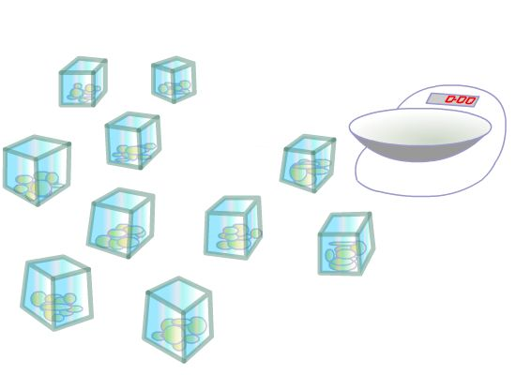
You have ten identical open-topped boxes with 10 visually identical coins in each.
In nine of the boxes each of the 10 coins has a mass of 10g.
In one box the 10 coins have masses of only 9g each.
How can you find which box is the odd one out?
You have a normal mass measurer with a single pan and a scale.
With just one weighing you can identify the box with the lighter coins.

What will you weigh?

Pies

Stage: 2

Grandma had made pies for a bake sale. She had carefully put equal amounts of mixture in each pie tin and was now trying to find the weight of the pies.
She had a problem; she only had one 200 gram weight and one 125gram weight.
She found that one pie balanced on the scale with both weights and a quarter of a pie.
How heavy was each pie?

SOLUTIONS

What's My Weight?

From the picture of the scales, the apple must weigh less than the four weights altogether.
If the apple weighs 180g , for the scale to be balanced the weights would have to be 45g each because there are four of them. But we know from the picture that the apple weighs less than the weights put together, so each weight must be more than 45g .
If the apple weighed 375g , then for the scale to be balanced, each weight would be 93.75g . So, for the weights to be heavier than the apple, each one must be more than 375g .
One kilo is 1000g and four 250g weights would also weigh1000g altogether so the scale would be balanced.

Money Measure

Take one coin from the first box, two coins from the second box and so on. You will end up with 55 coins taken from the various boxes. Weigh the 55 coins. If the weight reads one gram less than 550 then 1 coin weighs 9 grams and box number 1 contains the light coins. If the weight reads 2 grams less than 550 then two coins weigh 9 grams and box number two contains the light coins and so on.

Pies
I got my answer of 433 1 3 grams by putting the problem into an equation. These are the steps I took to get the answer:
- First I did the sum 200g. + 125 g. which equalled325 g.
- Then I wrote it down like this: 325 g. + 1/4pie = pie
I then converted this to: 325 g. +1/4 pie =4/4pie (or one whole pie).
- Next, I took 1 4 of a pie from each side leaving me with: 325 g. = 3/4 pie.
- I multiplied each side by 4 which came out as: 1300 = 3 pies
- I divided each side by 3 and came to the final answer of:433 1/3grams = 1 pie."
Some Online Mass Sites
http://nrich.maths.org/4726
http://nrich.maths.org/public/leg.php?code=152

