MATHEMATICS STAGE 2
TEACHING AND LEARNING OVERVIEW
TERM: | WEEK: 17 | STRAND: Number and Algebra | SUB-STRAND: Multiplication and Division 2 | WORKING MATHEMATICALLY: MA2-1WM, MA2-2WM & MA2-3WM
OUTCOMES: MA2-6NA |  | Uses mental and informal written strategies for multiplication and division
CONTENT: |  | Recall multiplication facts up to 10 x 10 and related division facts  * Relate multiplication facts to their inverse division facts: e.g. 6 × 4 = 24, so 24 ÷ 6 = 4 and 24 ÷ 4 = 6.  * Students should come to understand that division “undoes” multiplication.  5 x 2 = 10 5 = 10 ÷ 2  10 ÷ 2 = 5 10 = 5 x 2
ASSESSMENT FOR LEARNING  (PRE-ASSESSMENT) |  | Division wheels or grids with dividend and one divisor recorded; students fill in missing divisor. Also there are other worksheets that can be generated at the following sites:  http://www.helpingwithmath.com/printables/worksheets/WorksheetGenerator04.htm  http://www.helpingwithmath.com/by_subject/multiplication/mul_tables_charts.htm
WARM UP / DRILL |  | CD with times tables songs.  Multiplication grids and 100 chart: http://splash.abc.net.au/res/i/L83/index.html  http://www.visnos.com/demos/times-tables
TENS ACTIVITY  NEWMAN’S PROBLEM  INVESTIGATION |  | Jennifer has 30 buttons. She uses 5 buttons on each shirt. How many shirts are there?  Students can rewrite this number problem using multiplication e.g. Jennifer has __ shirts. She uses 5 buttons on each shirt. How many buttons does she need altogether?
QUALITY TEACHING ELEMENTS |  | INTELLECTUAL QUALITY | QUALITY LEARNING ENVIRONMENT | SIGNIFICANCE
 |  | - Deep knowledge  - Deep understanding  - Problematic knowledge  - Higher-order thinking  - Metalanguage  - Substantive communication | - Explicit quality criteria  - Engagement  - High expectations  - Social support  - Students’ self-regulation  - Student direction | - Background knowledge  - Cultural knowledge  - Knowledge integration  - Inclusivity  - Connectedness  - Narrative
RESOURCES |  | Numeral and sign cards to make number sentences for multiplication and division. Cards that have two multiples and product; matching card with product divided by one of the multiples and space for answer.  IWB: times tables song - https://www.youtube.com/watch?v=igoGDE5hLjw  Arrays: http://splash.abc.net.au/res/i/L2059/index.html  http://www.k-5mathteachingresources.com/support-files/blanknumberlines.pdf

TEACHING AND LEARNING EXPERIENCE
WHOLE CLASS INSTRUCTION MODELLED ACTIVITIES | GUIDED & INDEPENDENT ACTIVITIES
Explicitly communicate lesson outcomes and work quality.  Teach and review  Numeral and symbol cards to make a multiplication sentence then show the inverse division sentence by moving the numeral cards and using the correct symbol.  Explain rows and columns in arrays. Give students a problem, such as 3×4 and model this problem on graph paper using counters. Emphasize this as 3 groups of 4, so you need three lines with four counters in each line. Also show how this is repeated addition, such as 3×4 = 4+4+4. The students are encouraged to transfer this information to division as repeated subtraction.  Define and Reinforce  metalanguage used in the unit:  Multiply, multiplied by product, multiplication, multiplication facts, tens, ones, double, multiple, (factor, shared between, divide, divided by, division, halve, remainder, equals, is the same as, strategy, digit). | LEARNING SEQUENCE  Remediation  S1 or Early S2 | Link multiplication and division facts using groups or arrays, e.g.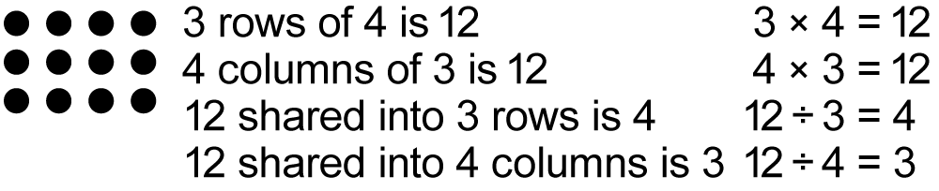  Explain why a rectangular array can be read as a division in two ways by forming vertical or horizontal groups, e.g. 12 ÷ 3 = 4 or 12 ÷ 4 = 3 (Communicating, Reasoning)
 | LEARNING SEQUENCE  S2 | Show numeral and symbol cards with related sentences, e.g.  9 x 2 = 18  18 ÷ 2 = __  Students represent each sentence with counters.  ● ● ● ● ● ● ● ● ●  ● ● ● ● ● ● ● ● ●  Ask students to complete the number sentences and explain how the cards are related and record the number sentences. Remind students to check answers against a multiplication chart.  Number trio cards 30  Children can state the four possible calculations. 5 6  Alternatively, they can suggest the hidden number when one corner is covered.  5 × 6 = 30; 6 × 5 = 30; 30 ÷ 6 = 5; 30 ÷ 5 = 6  Use a 100’s chart to highlight the multiplication factors for a chosen number on IWB or large chart. Students can highlight their own chart. This can be done for different numbers.  Investigation: As repeated addition is quicker using multiplication so repeated subtraction is quicker using division. The use of arrays can help with this exercise. For the inverse of 3 x 4 = 12 the students can record the solution in terms of repeated subtraction: 12 – 4 – 4 – 4 = 0. Then they record the solution using the division symbol: 12 ÷ 4 = 3. Continue with practise of this type of operation using number lines:  Template: http://www.k-5mathteachingresources.com/support-files/multfacttriangle.pdf
 | LEARNING SEQUENCE  Extension  Late S2 or Early S3 | - Use the appropriate operation when solving problems in real-life situations (Problem Solving): Do I need to multiply or divide?  - Use inverse operations to justify solutions (Problem Solving, Reasoning): if I use the opposite operation are the numbers inverted?  - Use the term 'quotient' to describe result of a division calculation, eg 'The quotient when 30 is divided by 6 is 5'
 | EVALUATION & REFLECTION | Student engagement: Achievement of Outcomes:  Resources: Follow up:

