MATHEMATICS STAGE 1
TEACHING AND LEARNING OVERVIEW
TERM: | WEEK: 3 | STRAND: Number and Algebra | SUB-STRAND: Patterns and Algebra 1 | WORKING MATHEMATICALLY:  MA1-1WM, MA1-2WM
OUTCOMES: MA1-8NA |  | Creates, represents and continues a variety of numbers and objects.
CONTENT: |  | Investigate and describe patterns formed by skip counting and patterns with objects.  - Describe how number patterns are made and how they can be continued (Communicating, Problem Solving)  - Create, record and describe number patterns that increase or decrease.
ASSESSMENT FOR LEARNING  (PRE-ASSESSMENT) |  | - Make a Number Pattern: Students are asked to make a number pattern that increases, or a number pattern that decreases. Can they explain why a particular number is/is not used in their number patterns? Can they continue their number pattern?
WARM UP / DRILL |  | - Finding a Partner: Students line up in twos to investigate whether every student in the class will have a partner. As a whole class, they count the rows of students: 2, 4, 6, 8, ……… The teacher explains that these are even numbers.

TENS ACTIVITY

NEWMAN’S PROBLEM

INVESTIGATION

QUALITY TEACHING ELEMENTS |  | INTELLECTUAL QUALITY | QUALITY LEARNING ENVIRONMENT | SIGNIFICANCE
 |  | - Deep knowledge  - Deep understanding  - Problematic knowledge  - Higher-order thinking  - Metalanguage  - Substantive communication | - Explicit quality criteria  - Engagement  - High expectations  - Social support  - Students’ self-regulation  - Student direction | - Background knowledge  - Cultural knowledge  - Knowledge integration  - Inclusivity  - Connectedness  - Narrative
RESOURCES |  | Websites: Count Me in Too; http://www.cheekymonkeyresources.co.uk/Sequencenew/SEQUENCE.htm http://www.topmarks.co.uk/Flash.aspx?f=SnowflakeSequencesv2 www.harcourtschool.com/activity/paul_pattern; www.wnet.org.uk/resources/gordan/counting; Talking about Patterns and Algebra, Dept of Ed book.

TEACHING AND LEARNING EXPERIENCES
WHOLE CLASS INSTRUCTION MODELLED ACTIVITIES | GUIDED & INDEPENDENT ACTIVITIES
- Model and describe patterns on a hundred chart.  - Model and describe patterns on a number line.  - Show forward and backward number patterns. Describe how you can work out the patterns.  - Explain why a particular number is/is not used in the number pattern.  - Sausage Counting – Explain to the students that butchers hang sausages in threes. Display 10 ‘Sausages’ cards on the floor. Have the students count the total number of sausages and record the total on the board. Remove one card at a time and have the students count and record the total number of the remaining sausages.  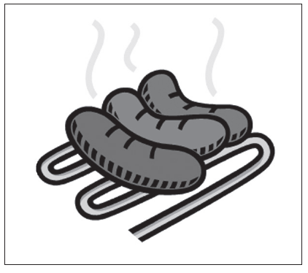 | LEARNING SEQUENCE  Remediation  ES1 | - Number patterns that increase  Display the number line. Students clip the pegs onto every second number on the number line. Students are to say the number that has the peg on it.  Repeat for other number sequences.  - Do this for both increasing and decreasing numbers.
 | LEARNING SEQUENCE  S1 | - Record the sequence 3, 6, 9, 12, 15 on the board and ask the students to work in pairs to continue the sequence and describe it. Repeat the activity for the following sequences:  30, 27, 24, 21, 18, ........ 1, 3, 6, 10, 15, .................. 1, 4, 7, 10, 13, .............  1, 2, 4, 8, 16, .............. 1, 3, 7, 13, 21, ...............  - Have the students set similar tasks for their peers.  - Skip counting to 24 – Ask students how many ways can they skip count to 24. Have them represent this on a number line, a hundred chart, through pictures and numbers.
 | LEARNING SEQUENCE  Extension  Early S2 | - Have the students investigate the sequences (using the addition of a table) created by repeatedly adding three to a number of their choice. Have the students record the first ten terms of the sequence in a table.
 | EVALUATION & REFLECTION
- All assessment tasks should be written in red and planning should be based around developing the skills to complete that task.
- Assessment rubrics or marking scale should be considered.

