MATHEMATICS STAGE 3
TEACHING AND LEARNING OVERVIEW
TERM: | WEEK: 7 | STRAND:  Numbers and Algebra |  | SUB-STRAND:  Patterns and Algebra 2 |  | WORKING MATHEMATICALLY:  MA3-3WM, MA3-2WM, MA3-3WM MA3-8NA
OUTCOMES:  MA3-8NA |  | Analyses and creates geometric and number patterns, constructs and completes number sentences, and locates points on the Cartesian plane
CONTENT: |  | Continue and create sequences involving whole numbers, fractions and decimals; describe the rule used to create the sequence (ACMNA133)  * Complete a table of values for number patterns involving one operation (including patterns that decrease) and describe the pattern in words, e.g. 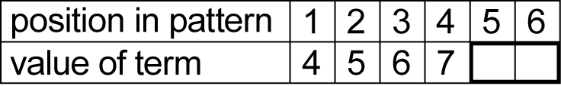  * Describe the pattern in a variety of ways and record descriptions in words, e.g. 'It goes up by ones, starting from four'  * Determine a rule to describe the pattern from the table, e.g. 'To get the value of the term, you add three to the position in the pattern'  * Use the rule to calculate the value of the term for a large position number, e.g. 'What is the 55th term of the pattern?'  * Explain why it is useful to describe the rule for a pattern by describing the connection between the 'position in the pattern' and the 'value of the term'  * Interpret explanations written by peers and teachers that accurately describe geometric and number patterns (Communicating)  * Make generalisations about numbers and number relationships, eg 'If you add a number and then subtract the same number, the result is the number you started with'
ASSESSMENT FOR LEARNING  (PRE-ASSESSMENT) |  | - Ask the students to write as many correct number patterns as possible in a fixed time limit. They must have 6-8 numbers in each sequence. Allocate points according to the operations they include. E.g. ascending patterns with addition and multiplication earn 5 points; descending patterns with subtraction and division earn 10 points; patterns with square numbers or square roots earn 15 points etc. (Select concepts relevant to the class experience.) Collate points and assign a winner/s. Use this time to make observations and anecdotal notes regarding student achievement.

WARM UP / DRILL
NEWMAN’S PROBLEM  INVESTIGATION |  | A new cookbook is becoming popular. The local bookstore ordered 100 copies in September, 110 copies in October, 120 copies in November, 130 copies in December, and 140 copies in January. If this pattern continues, how many copies will the bookstore order in February? How many copies have been required over the six months?
QUALITY TEACHING ELEMENTS |  | INTELLECTUAL QUALITY | QUALITY LEARNING ENVIRONMENT |  | SIGNIFICANCE
 |  | Deep knowledge  Deep understanding  Problematic knowledge  Higher-order thinking  Metalanguage  Substantive communication | Explicit quality criteria  Engagement  High expectations  Social support  Students’ self-regulation  Student direction |  | Background knowledge  Cultural knowledge  Knowledge integration  Inclusivity  Connectedness  Narrative
RESOURCES |  | See throughout…

TEACHING AND LEARNING EXPERIENCES
WHOLE CLASS INSTRUCTION MODELLED ACTIVITIES | GUIDED & INDEPENDENT ACTIVITIES
Continue to review and practise the tables of values and patterns explored in Weeks 1 and 2. Lots of varied examples and ongoing modelling will assist in the development of the students’ knowledge. Further skills to enhance the understanding of patterns can be explored through the following:  - INVERSE OPERATIONS  - Pose this problem for students to solve: I am thinking of a number. When I take 9 away from the number my answer is 19. What number am I thinking of?  - Students discuss and write a number sentence that could solve the problem. Compare responses. Determine that the number sentence could be either addition or subtraction, e.g.  - 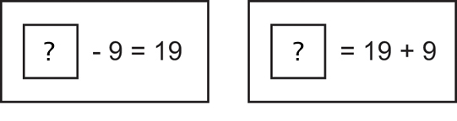  - Discuss what is meant by inverse operations.  Demonstrate how to complete a number of calculations working backwards. Talk aloud the strategy using mathematical language and point out the inverse operations being used.  - 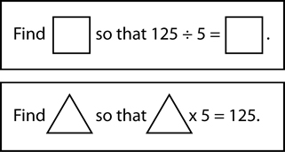  - Pair students and see if they can quiz each other each other using the mini whiteboards. Start with examples and then progress to the students creating their own. The purpose here is to get students to flip between multiplication and division operations in order to find the missing value.  WHAT OPERATION IS THAT?  - Students complete number sentences where the operation sign is missing. Set many and varied questions for the students to complete. Use all four operations and even more than 2 values on each side of the equation. Review and discuss findings and strategies. E.g. 4 ___ 4 = 32 ___ 2  Students record their findings in their book. See if the students can trick each other with challenging questions for their peers or teachers! Practise, practise, practise… extend using fractions and decimals.  3. WHAT NUMBER IS THAT?  Students complete number sentences by finding a missing number, e.g. 9 x ___ = 10 x 4.5  - Students write similar problems for their partner to complete. Ask students to verbalise strategies they know which would help them solve the calculations. In groups, have students explain the processes they used to solve the number sentences. Each group needs to devise a complicated equation and explain their chosen task to class. One option could be that each group role-plays a classroom where one member is the teacher. The teacher needs to explain to their class, how to complete the equation successfully. (Humour added to this activity makes it a lot of fun!) | LEARNING SEQUENCE  Remediation  S2 | - Review Week 1 and 2 Tasks. Practise number patterns online:  http://au.ixl.com/math/year-5  (There are other grade levels that can be addressed here.)
 | LEARNING SEQUENCE  S3 | - Red Dragonfly Mathematics Challenge:  https://detwww.det.nsw.edu.au/curr_support/maths/reddragonfly/q4.html  (You must be logged into the portal to access this. Some questions are great for mid and later stage 3; teachers will need to scan through to see what suits.)
 | LEARNING SEQUENCE  Extension  Early S4 | - Building Shapes worksheet and instructions: http://www.curriculumsupport.education.nsw.gov.au/secondary/mathematics/assets/pdf/s4_teach_ideas/algebra/stage4/buildshapes.pdf and http://www.curriculumsupport.education.nsw.gov.au/secondary/mathematics/assets/pdf/s4_teach_ideas/algebra/stage4/pabuildshape.pdf
 | EVALUATION & REFLECTION | - Evaluate the level of engagement in the activities presented. How did the students respond? Would you use these activities again? How could you do it differently? What was the best part of the lesson… why?
.

