MATHEMATICS STAGE 3
There have been 6 weeks allocated to the Cartesian Plane, as it is a new concept from Stage 4. There needs to be flexibility in addressing this content. The Cartesian Plane is potentially, a very foreign idea to explore due to the need to have a solid understanding of +/- numbers as well as a sound spatial awareness.
TEACHING AND LEARNING OVERVIEW
TERM: | WEEK: 8-9 | STRAND: Numbers and Algebra |  | SUB-STRAND: Patterns and Algebra 2 |  | WORKING MATHEMATICALLY:  MA3-3WM, MA3-2WM, MA3-3WM
OUTCOMES:  MA3-8NA |  | Analyses and creates geometric and number patterns, constructs and completes number sentences, and locates points on the Cartesian plane
CONTENT: |  | Introduce the Cartesian coordinate system using all four quadrants (ACMMG143)  * Recognise that the number plane consists of a horizontal axis (x-axis) and a vertical axis (y-axis), creating four quadrants 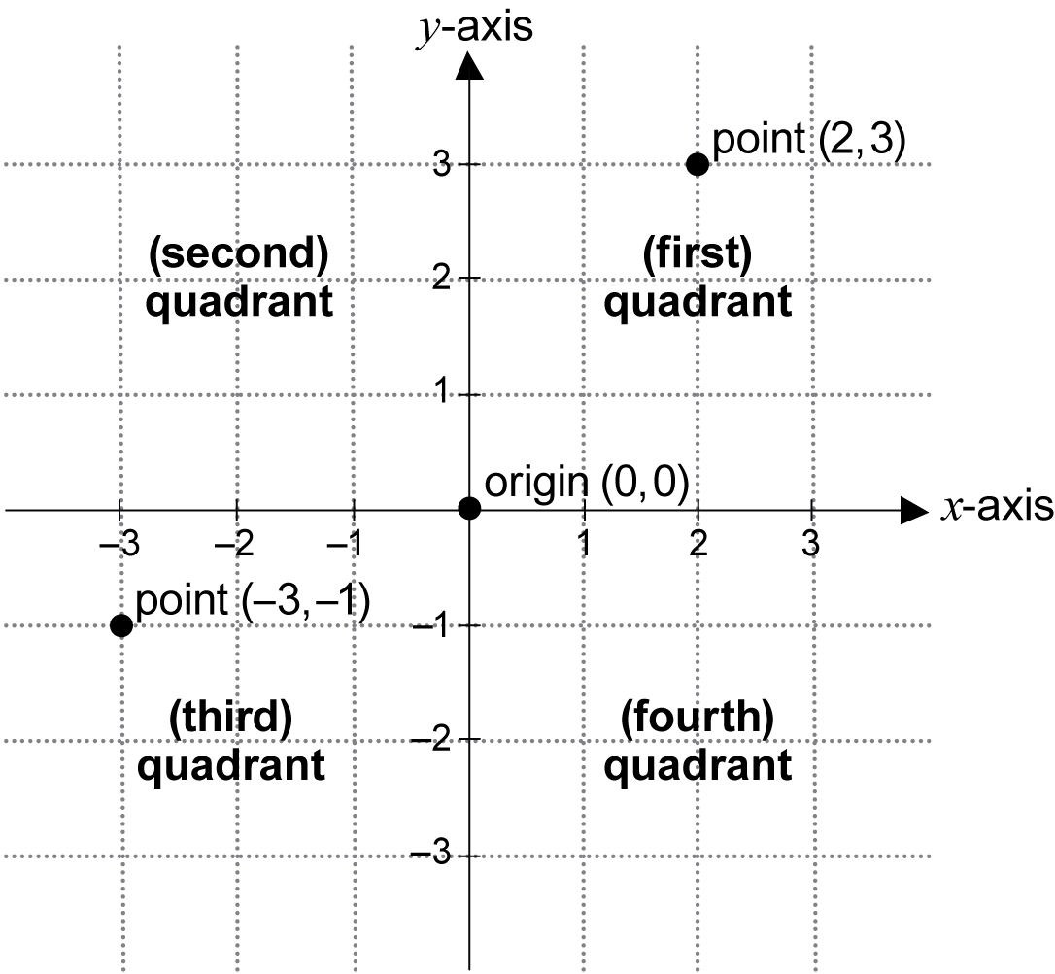  * Recognise that the horizontal axis and the vertical axis meet at right angles (Reasoning)
ASSESSMENT FOR LEARNING |  | - Review positive and negative numbers. Students need to create number lines that begin and end with a variety of values. (It is possible that there will need to be a lot of revision of previously taught concepts in number and consolidation of spatial awareness, in order to have an understanding of the number plane.)

WARM UP / DRILL
TENS ACTIVITY  NEWMAN’S PROBLEM  INVESTIGATION |  | - Roman Civilization began in 509 B.C. and ended in 476 A.D. How long did Roman Civilization last?  - In a quiz two points are scored for each correct answer but two points are deducted if an answer is wrong. If a team has a score of minus 12, how many correct answers will they need to reach a score of 20?
QUALITY TEACHING ELEMENTS |  | INTELLECTUAL QUALITY | QUALITY LEARNING ENVIRONMENT |  | SIGNIFICANCE
 |  | Deep knowledge  Deep understanding  Problematic knowledge  Higher-order thinking  Metalanguage  Substantive communication | Explicit quality criteria  Engagement  High expectations  Social support  Students’ self-regulation  Student direction |  | Background knowledge  Cultural knowledge  Knowledge integration  Inclusivity  Connectedness  Narrative
RESOURCES |  | Scootle resources  M010539 Interactive animation introducing the first quadrant of the Cartesian plane before introducing the other three quadrants  M010540 Explanation and short exercises on the first quadrant of the Cartesian plane before extending to the other three quadrants  Other Resources  Masking tape or chalk  Labels of the features of a Cartesian plane  For the teacher: www.shodor.org/interactivate/discussions/IntroductionToTheCoo/

TEACHING AND LEARNING EXPERIENCES
WHOLE CLASS INSTRUCTION MODELLED ACTIVITIES | GUIDED & INDEPENDENT ACTIVITIES
- Activity: Creating a Colossal Cartesian Plane  This activity is best completed on a large flat space, such as the floor of the school hall or a playground. A space that has a square-grid structure (eg the grout lines separating large square tiles) is preferable, if available. If the space to be used does not have a square-grid structure, the teacher should create a square grid of 30 units × 30 units prior to the activity. In addition, construct a large-scale number line through the middle of the grid labelled from –15 to 15.  - Introduce terminology associated with the Cartesian plane and use either large prepared labels or chalk to label these on the colossal Cartesian plane. It is important that students realise that, by convention, mathematicians refer to the horizontal axis as the ‘x-axis’, and the vertical axis as the ‘y-axis’. This allows a common understanding of the Cartesian plane in all parts of the world. Terminology to be introduced includes:  - ‘horizontal axis’ (‘x-axis’), ‘vertical axis’ (‘y-axis’), ‘intersect’: the number plane is created using two axes, the horizontal axis (x-axis) and the vertical axis (y-axis), which intersect at right angles  - ‘point of intersection’, ‘origin’: the name given to the point of intersection of the axes of the Cartesian plane is the origin. Students should be made aware that, by convention, the origin is denoted by the capital letter O  - ‘quadrant’: the axes divide the Cartesian plane into four quadrants (remind students of the word stem ‘quad-’, meaning ‘four’, and recall known words that use this stem, eg ‘quadrilateral’).  - With the aid of the labels, and later without, students practise responding to the terminology as the teacher asks all students (or a single student) to move to that feature of the Cartesian plane, eg ‘Ali, go to the origin’, ‘Everyone stand on the x-axis’, ‘Tam, go to the point of intersection of the axes’. | LEARNING SEQUENCE  Remediation  S2 | - As this is a new concept for Stage 3, reviewing the students’ understanding of number lines, positive and negative numbers would be helpful.  - Students with EAL/D or learning difficulties may require additional assistance due to the high literacy demands of this unit. These students could work in pairs, or a list of the points to be used could be given to them prior to the lesson.
 | LEARNING SEQUENCE  S3 | - Review the concept of positive and negative numbers (integers) and model the placement of integers on the large-scale number line.  - Call out numbers from –15 to 15 and have each student, one by one, find the specified position on the number line. Continue until all students have a position on the number line.  Adjustment: Reinforce associated terminology when discussing position on the number line through the use of ‘left’/‘negative’ and ‘right’/‘positive’.  - Explain that the number line allows us to identify a particular position on a single line using a number, but that this limits us to describing position only on the one line. Ask a few students to find a position nearby that is not on the line (include positions on both sides of the line).  - Generate discussion about how the position of someone who is not on the line could be described. Guide students to think of the important features needed to describe position accurately, such as:  - side of the line  - distance from the line.  - Guide student responses to the idea of two number lines placed at right angles to each other and intersecting at zero on each line. Use masking tape or chalk to construct the second number line on the ground from (roughly) –15 to 15 using the same scale as on the first line.  - Introduce the term ‘number plane’ and inform students that René Descartes was one of the first mathematicians to represent position in two dimensions using this method, hence the title ‘Cartesian plane’.
 | LEARNING SEQUENCE  Extension  Early S4 | Variations/Extensions  - Students can be introduced to the convention of naming the quadrants, starting with the ‘first quadrant’, being that in which both the x- and y-coordinates are positive, and then moving in an anticlockwise direction around the Cartesian plane. This convention of naming the quadrants is important in the study of trigonometry in Stages 5 and 6.  - Some students may research the life and mathematical discoveries of René Descartes and create a book or display for the classroom.
 | EVALUATION & REFLECTION | - Mathematics Learning Journal Entry – What do I know? What do I want to know?  - Discussion with students around: What have we learnt and where to next?
.

