MATHEMATICS STAGE 2
TEACHING AND LEARNING OVERVIEW
TERM: | WEEK: 1 | STRAND: Measurement and Geometry | SUB-STRAND: Position 1 | WORKING MATHEMATICALLY:  MA2-1WM
OUTCOMES: MA2-17MG |  | Uses simple maps and grids to represent position and follow routes, including using compass directions.
CONTENT: |  | Create and interpret simple grid maps to show position and pathways (ACMMG065)  - describe the location of an object using more than one descriptor, e.g. 'The book is on the third shelf and second from the left'  - use given directions to follow routes on simple maps  - use and follow positional and directional language (Communicating)  - use grid references on maps to describe position, e.g. 'The lion cage is at B3'  - use grid references in games (Communicating)  - identify and mark particular locations on maps and plans, given their grid references  - draw and label a grid on a given map  - discuss the use of grids in real-world contexts, e.g. zoo map, map of shopping centre (Reasoning)
ASSESSMENT FOR LEARNING  (PRE-ASSESSMENT) |  | - Bee Bots or Pro Bots to assess the prior knowledge and language of students in regards to location and position.  The Bee Bots could be a starting point for teaching directional language and basic programming to students (Incorporating ICT)
WARM UP / DRILL |  | - Learning Sequence 1 (Warm Up): Talking Directions  Work with a partner or small group and brainstorm as many words as you can to describe direction (THINK, PAIR, SQUARE).  Discuss how these words help us to communicate in terms of positional language.  Use examples to have the students communicate position.  - Learning Sequence 2 (Warm Up): Model Farm  In small groups, students make a model of a farm using small toys and or pictures. Students are asked to describe the position of objects in relation to other objects e.g. ‘The horses are next to the cows’, ‘The stable is behind the farmhouse.’ Discuss language features and terms ‘left’, ‘right’, ‘in-between’, ‘behind’, ‘in front’ etc.  - Learning Sequence ICT (Warm Ups):  - ICT Warm Up (Links)  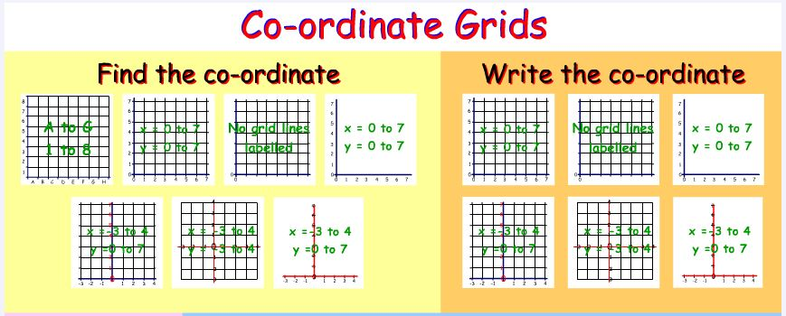
TENS ACTIVITY  NEWMAN’S PROBLEM  INVESTIGATION |  | Newman’s Problem  Using the resource from Maths Trail –Stage 2 ‘Taronga Zoo-Zoo Education’ WMS 2.3 & SGS 2.3 – Communicating and Position  You are at the Dingo exhibit and realise you have left something behind at the Wapiti. On the map trace the route you would take to go from the Dingos to the Wapiti (remember you can only travel on the roads or the walking tracks) Make a list of the animals you would pass traveling between the two exhibits. Extension: Could you estimate the distance between the two exhibits?  Teacher observes and records (rubrics) the positional language used and the understanding of the position.
QUALITY TEACHING ELEMENTS |  | INTELLECTUAL QUALITY | QUALITY LEARNING ENVIRONMENT | SIGNIFICANCE
 |  | - Deep knowledge  - Deep understanding  - Problematic knowledge  - Higher-order thinking  - Metalanguage  - Substantive communication | - Explicit quality criteria  - Engagement  - High expectations  - Social support  - Students’ self-regulation  - Student direction | - Background knowledge  - Cultural knowledge  - Knowledge integration  - Inclusivity  - Connectedness  - Narrative
RESOURCES |  | Digital and Interactive Resources  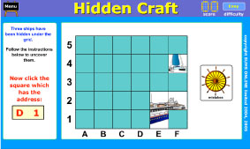  iPad app Battleship  (FREE)  Maths K-6 Using Maths Tracks (Dept. of Education and Training Document) Space and Geometry- Position (Centre for Learning Innovation).  http://www.curls.edu.au/search.php/all/position%202A  Space and Geometry –Position Stage 2 NAPLAN https://edod.det.nsw.edu.au/PDFs/NAPLAN/2009/Links/numeracy/nn_spac/nn_spac_s2c09.htm  Metalanguage signage posters and cue cards to assist students with the positional language needed to complete learning activities.

OLE CLASS INSTRUCTION MODELLED ACTIVITIES | GUIDED & INDEPENDENT ACTIVITIES
Explicitly communicate lesson  outcomes and work quality.  Teach and review  When using grid-reference systems, such as those found on maps, the horizontal component of direction is named first, followed by the vertical component.  Define and Reinforce  metalanguage used in the lesson  sequences  Discuss and reinforce positional language:  Position, location, map, plan, path, route, grid reference, aerial view, legend, key scale, directions, north, south, east, west… etc.  Digital Resources  * See resource list  Revise  Vertical and horizontal referencing and positional language | LEARNING SEQUENCE  Remediation  S1 or Early S2 | Have the students design and create a Pirate Treasure Map using the Pirate  Map Template and picture cards. Have the students discuss their map reinforcing the  metalanguage used: position, ‘in front’, ‘behind’, beside’, ‘opposite’’ ‘to the left of’ etc.  Use a transparency grid template to lay over the Pirate Treasure Map and discuss how we  can use co-ordinates to assist with position and location.  Use the Digital Resources listed to reinforce and consolidate these concepts.
 | LEARNING SEQUENCE  S2 | Learning Sequence 1: Mystery Location  Students are asked to describe the location of an object in the classroom e.g. ‘My picture is  fifth from the left and it’s in the second row on the back wall’. Students write a description  of the object using positional clues. The teacher collects the clues and reallocates them back  to the students. Students read the descriptions and locate the object.  Extension: In pairs, Student A hides an object in the room while Student B turns away.  Student A gives Student B directions to find the hidden object. Student B then has a turn at  hiding the object.  Learning Sequence 2: Positional Language  2A The students choose an interesting place within the school grounds or local area. The  students write the directions to give to another person or visitor to follow and find your  place of interest.  2B The teacher provides each student with grid paper marked with coordinates. Students are  asked to draw a map of the room or playground using the grid paper. They are asked to  include an arrow on their map to indicate North. Students choose two rooms or playground  features and label them A and B. They determine the set of co-ordinates for A and B and use  directional language to describe the location of other room/playground features related to A  and B. In groups, they brainstorm the positional language required to complete the activity.  Learning Sequence 3: Model Farm Grid  3A In small groups, students make a model of a farm using small toys and or pictures on a  grid. Students are asked to describe the position of objects in relation grid co-ordinates. ‘The  horse is at C3’; ‘The stable is at D9.’ Discuss co-ordinate features using letters and number  etc.  3B Use directions to explain the shortest route home. Design and create a map that has a  different of possible directions from home to school or home to the shopping centre etc.  Have students explore the different routes or paths and which is best, shortest, longest etc.  Have prepared grids and routes prepared for initial routes, then allows the students to  create their own maps.
 | LEARNING SEQUENCE  Extension  Late S2 or Early S3 | Differentiation  Learning Sequence: (Cartesian Co-ordinates) Differentiation  Have students investigate Cartesian grids and Co-ordinates (Positive and Negative numbers  and quadrants). Students learn to plot on positive / negative aspect of x and y axis.
 | EVALUATION & REFLECTION | Using a rubric, assess and record students’ use of directional language during the pre-assessment task with Bee Bots.
- All assessment tasks should be written in red and planning should be based around developing the skills to complete that task.
- Assessment rubrics or marking scale should be considered.

