MATHEMATICS STAGE 2
TEACHING AND LEARNING OVERVIEW
TERM: | WEEK: 2 | STRAND: Measurement and Geometry | SUB-STRAND: Position 1 | WORKING MATHEMATICALLY:  MA2-1WM
OUTCOMES: MA2-17MG |  | Uses simple maps and grids to represent position and follow routes, including using compass directions.
CONTENT: |  | Create and interpret simple grid maps to show position and pathways (ACMMG065)  - describe the location of an object using more than one descriptor, e.g. 'The book is on the third shelf and second from the left'  - use given directions to follow routes on simple maps  - use and follow positional and directional language (Communicating)  - use grid references on maps to describe position, e.g. 'The lion cage is at B3'  - use grid references in games (Communicating)  - identify and mark particular locations on maps and plans, given their grid references  - draw and label a grid on a given map  - discuss the use of grids in real-world contexts, e.g. zoo map, map of shopping centre (Reasoning)
ASSESSMENT FOR LEARNING  (PRE-ASSESSMENT) |  | - Worksheet and Bee Bots or Pro Bots to assess the prior knowledge and language of students in regards to location and position.  - The Bee Bots could be a starting point for teaching directional language and basic programming to students (Incorporating ICT)
WARM UP / DRILL |  | - Learning Sequence 1 (Warm Up): Positional Concentration  Using the IWB or traditional cards with positional words and or symbols create a game of concentration where the students need to use positional language to describe the matching cards in regards to location and position. Refer to glossary or language components to these lesson sequences.  - Learning Sequence ICT (Warm Ups):  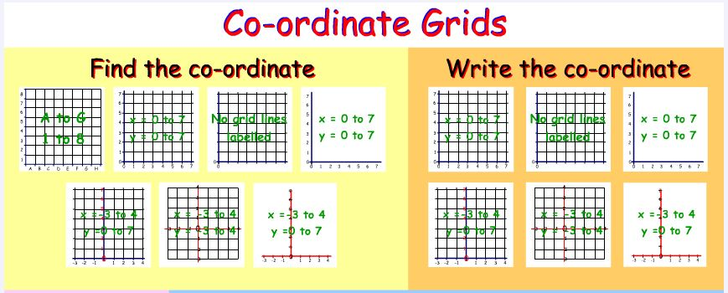  - ICT Warm Up (Links)
TENS ACTIVITY  NEWMAN’S PROBLEM  INVESTIGATION |  | Newman’s Problem  Using the resource from Maths Trail –Stage 2 ‘Taronga Zoo-Zoo Education’ WMS 2.3 & SGS 2.3 – Communicating and Position  (See Resources and attachments).  You are at the Dingo exhibit and realise you have left something behind at the Wapiti. On the map trace the route you would take to go from the Dingos to the Wapiti (remember you can only travel on the roads or the walking tracks) Make a list of the animals you would pass traveling between the two exhibits. Extension: Could you estimate the distance between the two exhibits?  Teacher observes and records (rubrics) the positional language used and the understanding of the position.
QUALITY TEACHING ELEMENTS |  | INTELLECTUAL QUALITY | QUALITY LEARNING ENVIRONMENT | SIGNIFICANCE
 |  | - Deep knowledge  - Deep understanding  - Problematic knowledge  - Higher-order thinking  - Metalanguage  - Substantive communication | - Explicit quality criteria  - Engagement  - High expectations  - Social support  - Students’ self-regulation  - Student direction | - Background knowledge  - Cultural knowledge  - Knowledge integration  - Inclusivity  - Connectedness  - Narrative
RESOURCES |  | Digital and Interactive Resources  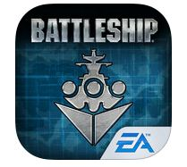  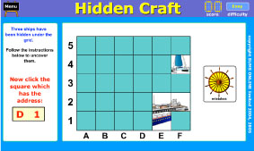  iPad app Battleship  (FREE)  Maths K-6 Using Maths Tracks (Dept. of Education and Training Document) Space and Geometry- Position (Centre for Learning Innovation).  http://www.curls.edu.au/search.php/all/position%202A  Space and Geometry –Position Stage 2 NAPLAN https://edod.det.nsw.edu.au/PDFs/NAPLAN/2009/Links/numeracy/nn_spac/nn_spac_s2c09.htm  Metalanguage signage posters and cue cards to assist students with the positional language needed to complete learning activities.

TEACHING AND LEARNING EXPERIENCES
WHOLE CLASS INSTRUCTION MODELLED ACTIVITIES | GUIDED & INDEPENDENT ACTIVITIES
Explicitly communicate lesson  outcomes and work quality.  Teach and review  When using grid-reference systems, such as those found on maps, the horizontal component of direction is named first, followed by the vertical component. This is a precursor to introducing coordinates on the Cartesian plane in Stage 3 Patterns and Algebra, where the horizontal coordinate is recorded first, followed by the vertical coordinate.  Define and Reinforce  metalanguage used in the lesson  sequences  Discuss and reinforce positional language:  Position, location, map, plan, path, route, grid reference, aerial view, legend, key scale, directions, north, south, east, west… etc.  Digital Resources:  * See digital resources above | LEARNING SEQUENCE  Remediation  S1 or Early S2 | Have the students design and create a map of their home from a Bird’s Eye view.  Discuss their map reinforcing the metalanguage used: position, ‘in front’, ‘behind’, beside’,  ‘opposite’’ ‘to the left of’ etc.  Use a transparency grid template to lay over their Bird’s Eye View Map and discuss how we  can use co-ordinates to assist with position and location.  Use the Digital Resources listed to reinforce and consolidate these concepts.
 | LEARNING SEQUENCE  S2 | Learning Sequence 4: Classroom Grids  Students arrange classroom desks into rows and column. Each desk is given a designated  colour and number (from the front / left to right). Give the students a grid position to be  seated at. Encourage students communicate position and location. Have the students swap  positions in seating allocation by: Swap positions of B1 and D7. You could allocate half the  class with a symbol or tag and try and have the class work as teams to have their assigned  symbol in one complete row before the other team. (Similar to connect four type of activity).  Learning Sequence 5: Seating Plans (Collaboration Teams)  Students investigate different online seating plans for theatres, stadiums etc.  Have the students draw a seating plan for a school performance or play in the school  assembly hall. Have the students organise the seating plan as co-ordinates. Students  produce numbered tickets (ICT) and distribute them. Have the students role play the  performance and seating arrangements to ensure success (and or) using the IWB to test  their planning and seating arrangements with ticket distribution.  - Investigation: Introducing Compass Points  Construct a compass using a saucer of water, a slice of cork, a needle and a magnet.  Instructions:  - Place the cork on the water  - Rub the magnet one way along the needle repeatedly until magnetised  - Lay the needle on the cork. The needle will swing in a north-south direction  - When the needle stops mark north, South, East and West on the saucer  Explain to students the four main points of the compass  Confirm the results from the experiment with a standard compass.  Label walls of the classroom with North, South, East and West.  Discuss how compass directions are used with position and mapping.  A good way to introduce the content in Position 2  - Reinforcement Activity: Body Turns  Mark the four major compass points in the room or on the ground. Have the student face north. Students are asked to turn left or right in quarter turns and state in which direction they then face.  Students are given north and are then asked to face particular compass directions.  Students record on a compass rose  - Extension:  NE, NW, SE and SW are introduced to describe places that lie between N,S,E and W.
 | LEARNING SEQUENCE  Extension  Late S2 or Early S3 | Differentiation  Learning Sequence (Extension) Differentiation  Students draw a 6 × 6 grid and label the axes 1 to 6 and A to F. In pairs, students take turns to  tell the other player where to put their counter. The winner is the first to set four of their  own counters at the corners of a square.  Variation: In pairs, students draw a picture/pattern on the  6 × 6 grid and tell the other student how to draw the picture or pattern. They could use the  computer to reproduce their pictures or patterns. (ICT)
 | EVALUATION & REFLECTION | - Students complete the assessment task on Position 1
- All assessment tasks should be written in red and planning should be based around developing the skills to complete that task.
- Assessment rubrics or marking scale should be considered.

Stage 2 Assessment Task Position 1
Outcomes:
SGS2.3 Uses simple maps and grids to represent position and follow routes.
WMS2.3 Uses appropriate terminology to describe, and symbols to represent mathematical ideas

Prior Learning and Assessment Task
Student will use their prior knowledge and understanding of position gained through the lessons to construct a simple map/plan of their bedroom, classroom or playground.
The students will draw their design on a provided grid.
Students will be asked to demonstrate their understanding of co-ordinates by locating key features on their map/plan.

Achievement Criteria Rubric
Students construct a simple map.
Students plot coordinates on their map and include a key.
Possible questions:
Can you construct a simple map or plan using coordinates?
Does your key allow you to locate specific objects?
Can you draw a path from one point to another on you map/plan?
Can you use directions to follow a route on your map?
Can you describe the location of an object in relation to another using more than one descriptor?
Can you describe the position of ……… using coordinates?

Achievement Criteria Rubric

Task Skill | Outstanding | High | Sound | Developing
SG2.3  Describes the location of an object on a simple map using co-ordinates and directions. | I am able highly proficient in describing the location of objects on a simple map using coordinates and directions and independently with insight and I can apply this knowledge to other areas. | I am able to efficiently describe the location of objects on a simple map using coordinates and directions efficiently and independently with insight. | I am able to effectively describe the location of objects on a simple map using coordinates and directions. | I am developing my skills to describe an object using coordinates.
SG2.3  Describes map/ routes with positional language | I am highly proficient in communicating co-ordinates, directions and routes using effectively positional language.. | I am proficient in communicating co-ordinates, directions and routes using effectively positional language. | I am effective in communicating co-ordinates, directions and routes using effectively positional language.. | I am developing my skills in communicating co-ordinates, directions and routes using effectively positional language.
SG2.3  Uses simple maps and grids to represent position and follow routes | I am highly proficient in communicating co-ordinates, directions and routes using effectively positional language to articulate and write and set of directions. | I am proficient in communicating co-ordinates, directions and routes using effectively positional language to articulate and write and set of directions. | I am effective in communicating co-ordinates, directions and routes using effectively positional language to articulate and write and set of directions. | I am developing my skills in communicating co-ordinates, directions and routes using effectively positional language to articulate and write and set of directions.
WMS2.3  Construct a simple map using a grid and use positional language to describe their map | I have an extensive understanding of the navigation tools in designing and creating simple maps with an extensive comprehension of the components of location and position. | I have a proficient understanding of the navigation tools in designing and creating simple maps with an excellent comprehension of the components of location and position | I have a component understanding of the navigation tools in designing and creating simple maps with a good comprehension of the components of location and position. | I am developing my understanding of the navigation tools in designing and creating simple maps with an increased comprehension of the components of location and position.

Name _________________________ Date __________

Assessment Task: Position 1

Task: Design and sketch a part of your favourite place in the playground.
Use grid paper or draw a grid for your map, and use positional language to describe how you would move from one point in the playground to another (path-ways).

My directions
_____________________________________________________________________________________________________________________________________________________________________________________________________________________________________________________________________________________________________________

