MATHEMATICS STAGE 1
TEACHING AND LEARNING OVERVIEW
TERM: | WEEK: 5 | STRAND:  Number and Algebra | SUB-STRAND:  Whole Numbers 1 | WORKING MATHEMATICALLY:  MA1-3WM & MA12WM
OUTCOMES: |  | MA1-1WM describes mathematical situations and methods using everyday and some mathematical language, actions, materials, diagrams and symbols  - MA1-2WM uses objects, diagrams and technology to explore mathematical problems  - MA1-3WM supports conclusions by explaining or demonstrating how answers were obtained  - MA1-4NA applies place value, informally, to count, order, read and represent two- and three-digit numbers
CONTENT: |  | Count collections to 100 by partitioning numbers using place value (ACMNA014)  - count and represent large sets of objects by systematically grouping in tens  - use and explain mental grouping to count and to assist with estimating the number of items in large groups  Recognise, model, read, write and order numbers to at least 100; locate these numbers on a number line (ACMNA013)  - represent two-digit numbers using objects, pictures, words and numerals  - locate and place two-digit numbers on a number line  - use number lines and number charts to assist with counting and ordering

ASSESSMENT FOR LEARNING
(PRE-ASSESSMENT)
WARM UP / DRILL |  | Buzz  Students stand in a circle. Select a number to count forwards or backwards by. When a designated number is reached (forwards) or zero (backwards) is said the next child is “buzz” and has to sit down. Last child standing is the winner. This game can be played with skip counting as well.

TENS ACTIVITY

NEWMAN’S PROBLEM

INVESTIGATION

QUALITY TEACHING ELEMENTS |  | INTELLECTUAL QUALITY | QUALITY LEARNING ENVIRONMENT | SIGNIFICANCE
 |  | - Deep knowledge  - Deep understanding  - Problematic knowledge  - Higher-order thinking  - Metalanguage  - Substantive communication | - Explicit quality criteria  - Engagement  - High expectations  - Social support  - Students’ self-regulation  - Student direction | - Background knowledge  - Cultural knowledge  - Knowledge integration  - Inclusivity  - Connectedness  - Narrative
RESOURCES |  | 100 chart, paper, paperclips, small objects for sorting,

TEACHING AND LEARNING EXPERIENCE
WHOLE CLASS INSTRUCTION MODELLED ACTIVITIES | GUIDED & INDEPENDENT ACTIVITIES
Groups of 10  Ask students to draw a picture of their two eyes and then to cut out each one. Provide students with paperclips so that the eyes remain in pairs.  Have students sit in a circle and place the eyes in the centre. Invite the group to estimate how many eyes there are altogether. Write several estimations on the board, with students’ initials next to each one.  Ask students to suggest ways of counting the eyes. Discuss strategies that might be easier. Explore students’ suggestions, such as counting by twos. Display a 100 chart and select a student to show on the chart the skips for each set of two eyes counted.  After counting approximately half the piles of eyes, ask students whether they wish to change their estimations. Make the changes suggested. Continue counting to check.  Ask: How many pairs of eyes would we need to make a group of 10 eyes?  Count with students to make piles of 10 eyes. Ask: How many groups of 10 do we have? Use the 100 chart to show the number for each group of 10 counted.  Ask: How many eyes are left over where we could not make a group of 10? Count on the additional eyes using the 100 chart.  Predicting Groups of 10  Have students sit in a circle and place 36 blocks spread out in the centre.  Ask students to predict how many groups of ten can be made with the blocks. Encourage students to explain the reasons for their suggestions.  Select a student to make three groups of ten and count the blocks left over. Write on the board ‘3 tens and 6’. Ask: How many blocks are there altogether?  Repeat with other 2-digit numbers. | LEARNING SEQUENCE  Remediation  ES1 | Mystery Number  Have pairs make three groups of ten unifix blocks, then place the groups of ten together to make a number line. One student chooses a number from a stack of numeral cards (0-30) and keeps it secret. The second student works out the mystery number by asking ‘more’ or ‘less’ questions. The second student places a counter on the number line to keep track of responses.  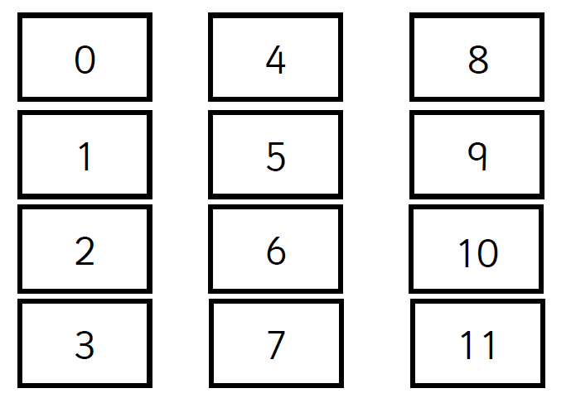  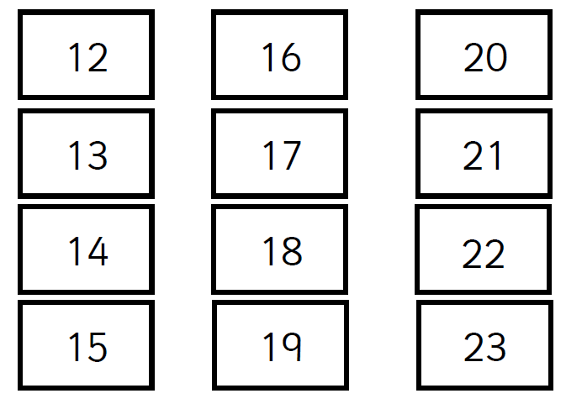  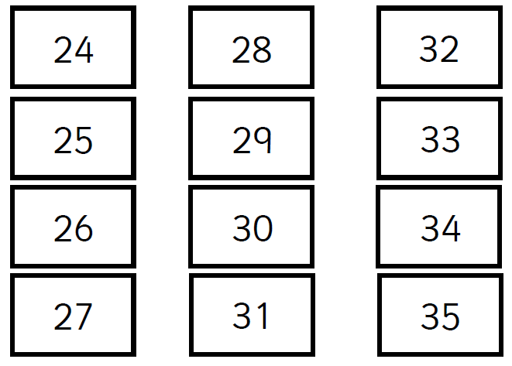
 | LEARNING SEQUENCE  S1 | Empty Number Lines  Students are given an empty number line that only shows the numbers at the start and at the end of the number line. On the reverse side all numbers are shown. A friend pegs on a peg on a particular number. The student then guesses the number. Their friend can say if the number is higher or lower. Continue until they have guessed the number. Change rolls.  Beat the Clock  Children practise filling in missing numbers on a hundreds square. When they have had enough practise they write the numbers one to one hundred in blank hundreds squares while you time them.  Have students choose a number between 10 and 30. Ask them to write the number and then draw their chosen number. Note whether students group the objects in tens in their drawings. Now invite students to choose a new number and use materials to sort into groups of ten. Have them write the number and draw the arrangement.
 | LEARNING SEQUENCE  Extension  Early S2 | Mystery Arrow Number (students will need to be able to count off the decade to complete this activity)  Students are given an almost blank 100s chart with three or four numbers left on the chart. The teacher tells students the number to play first eg, 35. The teacher then holds up an arrow. Students write the number that corresponds with the arrows direction where it belongs eg, 35 ↑ =25, 35 ←=24, 35 ↓=45 35 →=35 . When the teacher has shown a number and an arrow they ask a student for the answer. Then the process begins again at another number that was written on the chart.
 | EVALUATION & REFLECTION | Student engagement: Achievement of outcomes:  Resources: Follow up:

- All assessment tasks should be written in red and planning should be based around developing the skills to complete that task.
- Assessment rubrics or marking scale should be considered.

