MATHEMATICS STAGE 1
TEACHING AND LEARNING OVERVIEW
TERM: | WEEK: 6 | STRAND:  Number and Algebra | SUB-STRAND:  Whole Numbers 1 | WORKING MATHEMATICALLY:  MA1-3WM & MA12WM
OUTCOMES: |  | MA1-1WM describes mathematical situations and methods using everyday and some mathematical language, actions, materials, diagrams and symbols  - MA1-2WM uses objects, diagrams and technology to explore mathematical problems  - MA1-3WM supports conclusions by explaining or demonstrating how answers were obtained  - MA1-4NA applies place value, informally, to count, order, read and represent two- and three-digit numbers
CONTENT: |  | Count collections to 100 by partitioning numbers using place value (ACMNA014)  - count and represent large sets of objects by systematically grouping in tens  - use and explain mental grouping to count and to assist with estimating the number of items in large groups  - state the place value of digits in two-digit numbers, eg 'In the number 32, the "3" represents 30 or 3 tens'  Recognise, model, read, write and order numbers to at least 100; locate these numbers on a number line (ACMNA013)  - represent two-digit numbers using objects, pictures, words and numerals  - locate and place two-digit numbers on a number line  - use number lines and number charts to assist with counting and ordering  - apply an understanding of place value and the role of zero to read, write and order two-digit numbers
ASSESSMENT FOR LEARNING  (PRE-ASSESSMENT) |  | Before and After  Prepare “before and after” charts for each pair of students as shown in the diagram. Numerals are written down the centre column of the chart. These numerals should be within an appropriate range for the students. Students are given numeral cards to sort and place on the chart in either the “number-before” or “number-after” spaces to form number sequences.
WARM UP / DRILL |  | Squeeze  Display number line 0-100 in front of class. Place a peg on each end on 0 and 100. A child comes up the front and picks a number from 0-100 card pile and keeps it hidden. Other children ask questions about the mystery number, e.g. is it lower than 60? Is it odd? The card holder answers only yes or no and moves the pegs to squeeze the range of numbers to where children guess the correct number.
TENS ACTIVITY  NEWMAN’S PROBLEM  INVESTIGATION |  | Flash tens frames with regular and irregular dots. Have students explain how many they saw. Explicitly demonstrate the visualising technique.
QUALITY TEACHING ELEMENTS |  | INTELLECTUAL QUALITY | QUALITY LEARNING ENVIRONMENT | SIGNIFICANCE
 |  | - Deep knowledge  - Deep understanding  - Problematic knowledge  - Higher-order thinking  - Metalanguage  - Substantive communication | - Explicit quality criteria  - Engagement  - High expectations  - Social support  - Students’ self-regulation  - Student direction | - Background knowledge  - Cultural knowledge  - Knowledge integration  - Inclusivity  - Connectedness  - Narrative
RESOURCES |  | 100 chart, six sided dice, place value chart (tens and ones), number line (approximately two metres, made on the floor with masking tape and marked 0, 50, 100), unifix blocks, craft sticks, 100 grid, numeral cards (51-100).

TEACHING AND LEARNING EXPERIENCE
WHOLE CLASS INSTRUCTION MODELLED ACTIVITIES | GUIDED & INDEPENDENT ACTIVITIES
Explicit Teaching  Have students sit in a circle. Place two envelopes in the centre, one with 29 craft sticks and the other with 32 sticks, bundled into tens.  Show students only the single sticks from each envelope. Explain that there are also bundles of tens in each envelope. Ask: Which envelope has the most number of sticks?  Discuss the aspect that the bundles of tens need to be seen first to identify the bigger number of sticks. Show the bundles and have students compare the two quantities. Again ask: Which is bigger?  Show students the number line on the ground made from masking tape. Give three students each a box containing the different quantities of unifix blocks (15, 26, 19). Ask each one to show the tens and ones. Invite the class to decide where the students should stand on the number line.  Ask: How do we know that 51 is more than the 26? How do we know that 19 is less than 26?  Place another group of ten blocks with the 19 blocks. Ask students to compare and place the numbers on the number line. Ask: how do we know that 29 is more than 26?  ** It is important for students to understand that when they have zero ones, they must still write zero to hold its place value. | LEARNING SEQUENCE  Remediation  ES1 | Place Value using 100 Chart  Show students the 100 chart. Highlight the numbers 10 to 19.  Say: ‘I wonder what is the same about the ‘1’ in each of these numbers’.  Organise students into pairs. Ask them to use unifix blocks to investigate the numbers and find an answer to the problem.  Highlight the numbers 21 to 28: How many tens in each of these numbers? Again provide time for students to investigate. Ask: Is that true for the number 29?  Circle the number 34. Ask: Is it true that the 4 in the number means ‘four groups of ten’? Have students work with their partners to find an answer or prove that their response is true.  Place-Value Chart  Using a six sided die, students take turns rolling. Each time they roll the die they write the number down in the tens column, followed by the ones column.  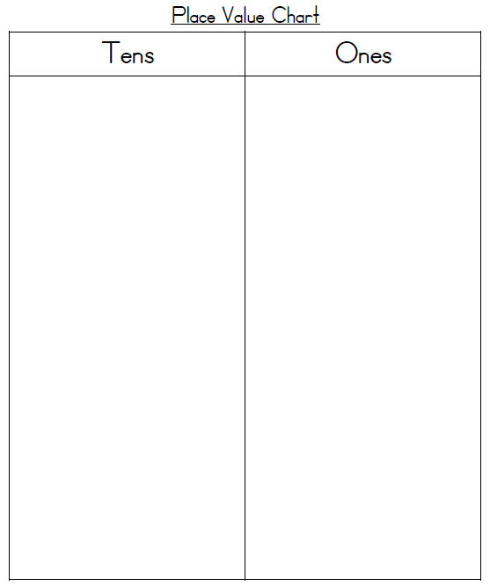
 | LEARNING SEQUENCE  S1 | In pairs, students select two cards from the 0-5 numeral cards. Ask them to place one numeral card on the place-value chart to show how many tens, and the other numeral card to show how many ones. Invite them to make the number using bundles of craft sticks.  Ask: Can you make a different number of sticks using the same two numeral cards?  Have students use a second place-value chart to explore a new number. Ask them to order the place-value charts from larger to smaller.  Assessment:  Provide students with numbers card showing 29, 41 and 14. Ask students to place the cards in order from smallest to largest. Provide four bundles of ten sticks and a pile of loose sticks. Ask each student to show you 36 sticks. If the student uses the loose sticks and counts by ones, ask: Is there an easier way of counting 36 sticks?
 | LEARNING SEQUENCE  Extension  Early S2 | 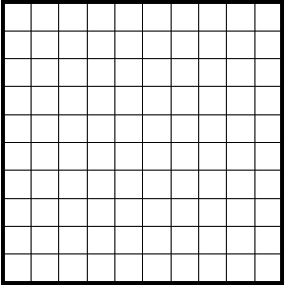  Provide students with several 100 grids.  Ask students to select a numeral card in the range 51-100. Have them  represent their chosen number by colouring in lines of tens and one  and writing the number underneath the grid. Repeat activity.
 | EVALUATION & REFLECTION | Student engagement: Achievement of outcomes:  Resources: Follow up:

- All assessment tasks should be written in red and planning should be based around developing the skills to complete that task.
- Assessment rubrics or marking scale should be considered.

