MATHEMATICS STAGE 1
TEACHING AND LEARNING OVERVIEW
TERM: 1 | WEEK: 7 | STRAND:  Number and Algebra | SUB-STRAND:  Whole Numbers 1 | WORKING MATHEMATICALLY:  MA1-3WM & MA12WM
OUTCOMES: |  | MA1-1WM describes mathematical situations and methods using everyday and some mathematical language, actions, materials, diagrams and symbols  - MA1-2WM uses objects, diagrams and technology to explore mathematical problems  - MA1-3WM supports conclusions by explaining or demonstrating how answers were obtained  - MA1-4NA applies place value, informally, to count, order, read and represent two- and three-digit numbers
CONTENT: |  | Count collections to 100 by partitioning numbers using place value (ACMNA014)  - count and represent large sets of objects by systematically grouping in tens  - use and explain mental grouping to count and to assist with estimating the number of items in large groups  - state the place value of digits in two-digit numbers, eg 'In the number 32, the "3" represents 30 or 3 tens'  - use place value to partition two-digit numbers, eg 32 as 3 groups of ten and 2 ones  - partition two-digit numbers in non-standard forms, eg 32 as 32 ones or 2 tens and 12 ones  Recognise, model, read, write and order numbers to at least 100; locate these numbers on a number line (ACMNA013)  - represent two-digit numbers using objects, pictures, words and numerals  - locate and place two-digit numbers on a number line  - use number lines and number charts to assist with counting and ordering  - apply an understanding of place value and the role of zero to read, write and order two-digit numbers  - give reasons for placing a set of numbers in a particular order (Communicating, Reasoning)  - solve simple everyday problems with two-digit numbers
ASSESSMENT FOR LEARNING  (PRE-ASSESSMENT) |  | 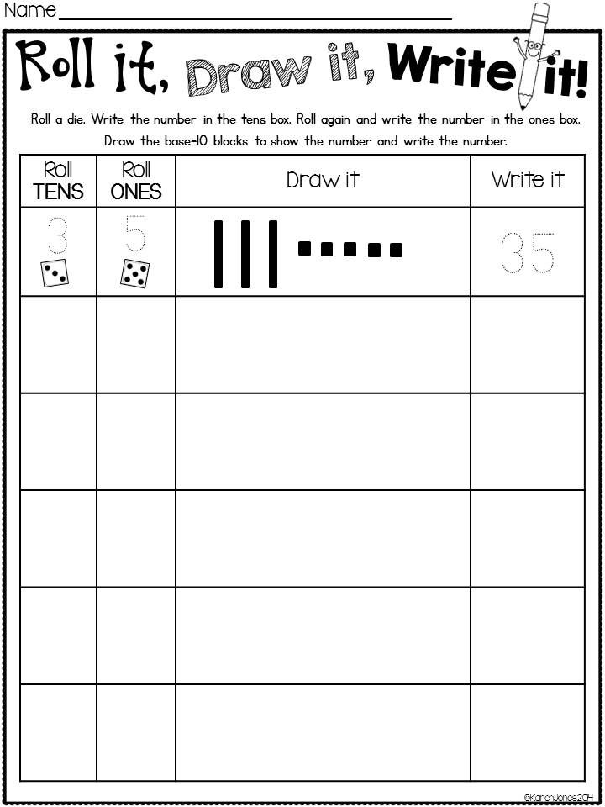  Roll It  Provide pairs with two dice and base ten materials. Students roll one die which represents the tens  value and then the other dice, which represents the ones value. Students then create this two digit  number using base ten blocks and record the information.
WARM UP / DRILL |  | Skip counting  Lead the students in oral counting in unison by tens, up to 100, and then backwards from 100. Support the oral counting by pointing to the location of these numbers on the one hundred chart. Cover the multiples of ten on the hundred chart and have a student point to the position of each number as the class counts forwards or backwards by ten. Vary the activity by using other counting patterns, such as counting by twos or counting by fives.
TENS ACTIVITY  NEWMAN’S PROBLEM  INVESTIGATION |  | Flash tens frames with regular and irregular dots. Have students explain how many they saw. Explicitly demonstrate the visualising technique.
QUALITY TEACHING ELEMENTS |  | INTELLECTUAL QUALITY | QUALITY LEARNING ENVIRONMENT | SIGNIFICANCE
 |  | - Deep knowledge  - Deep understanding  - Problematic knowledge  - Higher-order thinking  - Metalanguage  - Substantive communication | - Explicit quality criteria  - Engagement  - High expectations  - Social support  - Students’ self-regulation  - Student direction | - Background knowledge  - Cultural knowledge  - Knowledge integration  - Inclusivity  - Connectedness  - Narrative
RESOURCES |  | 100 chart, six sided dice, place value chart (tens and ones), number line (approximately two metres, made on the floor with masking tape and marked 0, 50, 100), unifix blocks, craft sticks, 100 grid, numeral cards (51-100), base ten materials.

TEACHING AND LEARNING EXPERIENCE
WHOLE CLASS INSTRUCTION MODELLED ACTIVITIES | GUIDED & INDEPENDENT ACTIVITIES
Explicit Teaching  Collections  Present students with a large collection of items, such as counters, pebbles, or buttons, a supply of containers, such as patty papers or cups, and a large sheet of cardboard. They will also need two sets of numeral cards ranging from zero to nine. Divide the chart into a “tens” and a “ones” column. Present the collection of items to the students and allow them to count the items. Each time ten items are collected, the students place the items into a container and move the container to the left-hand side of the chart, that is, onto the “tens” column. Students then place a numeral  card above the “tens” column, indicating how many groups of ten have been collected. As succeeding tens are collected, students continue to add them to the left-hand side of the chart and replace the numeral card accordingly. Remaining items are placed on the right-hand side of the  chart, in the “ones” column. Students then place a corresponding numeral card above the “ones” column to form a two-digit number.  Complete a variety of questions where students need to partition a two digit number. See examples below:  Numeral Expanders  Provide students with a numeral expander and base ten materials. Display a two digit number on the board eg 63.  Ask the students to create this number using their base ten materials.  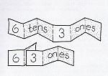  Display a numeral expander on the board and ask students to identify how many tens and how many ones they have.  Repeat activity with various two digit numbers. Once students have grasped this concept, introduce a hundreds numeral expander. | LEARNING SEQUENCE  Remediation  ES1  LEARNING SEQUENCE  S1 | Bucket count on  Drop a small collection of blocks one by one, into a bucket. Ask students to count aloud as each block is added to the container. After dropping the blocks, show the students the contents of the bucket. Then hold the bucket above the eye level of the students. Ask the students to state how many blocks would be in the bucket if one more block was added. Repeat the question, changing the number of blocks to be added to two and three blocks. Encourage the students to count on from the number of blocks already in the bucket to find the total.  Variation  Ask the students to pretend there are a nominated number of blocks in the bucket. Drop additional blocks into the bucket. Students count on to find the total sum of the blocks in the bucket.  Place Value using 100 Chart  Show students the 100 chart. Highlight the numbers 10 to 19.  Say: ‘I wonder what is the same about the ‘1’ in each of these numbers’.  Organise students into pairs. Ask them to use unifix blocks to investigate the numbers and find an answer to the problem.  Highlight the numbers 21 to 28: How many tens in each of these numbers? Again provide time for students to investigate. Ask: Is that true for the number 29?  Circle the number 34. Ask: Is it true that the 4 in the number means ‘four groups of ten’? Have students work with their partners to find an answer or prove that their response is true.  Place-Value Chart  Using a six sided die, students take turns rolling. Each time they roll the die they write the number down in the tens column, followed by the ones column.  Popsticks  Make a base board by folding a piece of paper or cardboard in half to form two columns. Label the columns as “units” and “tens”. Construct a set of numeral cards for the range one to nine on white cards. These cards will be used to represent numerals in the “tens” column on the chart. Construct  a second set of numeral cards in the range zero to nine on coloured card. These will be used to represent numerals in the “ones” column . Provide bundles of ten white popsticks and a pile of coloured popsticks. Shuffle the two decks of cards separately. Place the cards face down between the students. The students take turns to turn over a white card and a blue card to form a two-digit numeral and place the cards onto the chart. The students then read the numeral they have formed and collect a corresponding number of sticks, using the bundles of white popsticks and the coloured popsticks. Students then place the popsticks next to the numeral cards and allow others to verify that the number of popsticks used is correct.  Flip and see  Provide each student with a large collection of popsticks and a base board divided into a “tens” and a “ones” column. Place numeral cards in the range zero to nine face down on the floor. The students take turns to flip over two numeral cards and place one card in the tens column and one card in the ones column on their base board. Students then bundle popsticks into tens and place the correct number of bundles and units onto their base board to match the numeral cards. Discuss how many tens and ones were made.  Variations  • Students complete the above activity and then swap the numeral cards from the tens column to the units column and vice-versa. They then repeat the activity.  • Construct two sets of numeral cards in the range zero to nine. Flip over two numeral cards and ask the students to select identical numeral cards from the second set of cards. Ask students to place their cards in the tens and ones column so that they form the largest and the smallest number possible.  • Organise students into pairs and provide each pair of students with a set of numeral cards in the range zero to nine. The students shuffle the cards and place them face down on the floor. They then take turns to select two numeral cards. Using the two cards selected, each student forms the largest two-digit number possible. The two students then compare their numbers and the player with the larger number scores ten points. Continue playing until one player gains a score of one hundred.
 | LEARNING SEQUENCE  Extension  Early S2 | Introduce four digit numbers. Create a numeral expander (thousands). Provide students with ongoing opportunities to work with four digit numbers.  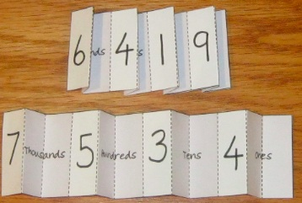
 | EVALUATION & REFLECTION | Student engagement: Achievement of outcomes:  Resources: Follow up:

- All assessment tasks should be written in red and planning should be based around developing the skills to complete that task.
- Assessment rubrics or marking scale should be considered.

