MATHEMATICS STAGE 3
TEACHING AND LEARNING OVERVIEW
TERM: | WEEK: 4 | STRAND: MEASUREMENT & GEOMETRY | SUB-STRAND: VOLUME AND CAPACITY 2 | WORKING MATHEMATICALLY:  MA3-1WM, MA3-2WM & MA3-3WM
OUTCOMES: MA3-11MG |  | Selects and uses the appropriate unit to estimate, measure and calculate volumes and capacities, and converts between units of capacity.
CONTENT: |  | Calculate the volumes of rectangular prisms.  - Describe the ‘length’ and ‘height’ of a rectangular prisms as the ‘dimensions’ of the prism  - Construct rectangular prisms using cubic-centimetre blocks and count the blocks to determine the volumes of the prisms  - Construct different rectangular prisms that have the same volume (Problem Solving)  - Explain that objects with the same volume may be different shapes (Communicating, Reasoning)  - Describe rectangular prisms in terms of layers, e.g. ‘There are 3 layers of 8 cubic-centimetre blocks’  - Recognise that rectangular prisms with the same volume may have different dimensions
ASSESSMENT FOR LEARNING  (PRE-ASSESSMENT) |  | - Brainstorm: Students estimate the volume of containers found around the room. Students are required to find three objects/containers that they believe have the same/similar volume.
WARM UP / DRILL |  | - Revise the cubic centimetre – students create 3D models using centicubes with a volume of 18${ cm}^{3}$, 26${ cm}^{3}$ and 35 ${ cm}^{3}$.  - Times Table Drill- students participate in a whole class times table game (e.g. Buzz Off, Bing Bang Bong, etc).
TENS ACTIVITY  NEWMAN’S PROBLEM  INVESTIGATION |  | - Sarah has two 3D shapes. Her first shape is 4 cubic centimetres wide, 5 cubic centimetres long and has a depth of 2 cubic centimetres. Sarah’s second shape is 2 cubic centimetres wide, 10 cubic centimetres long and has a depth of 2 cubic centimetres. What is the volume of each shape? Students may use centicubes to help with working out.
QUALITY TEACHING ELEMENTS |  | INTELLECTUAL QUALITY | QUALITY LEARNING ENVIRONMENT | SIGNIFICANCE
 |  | - Deep knowledge  - Deep understanding  - Problematic knowledge  - Higher-order thinking  - Metalanguage  - Substantive communication | - Explicit quality criteria  - Engagement  - High expectations  - Social support  - Students’ self-regulation  - Student direction | - Background knowledge  - Cultural knowledge  - Knowledge integration  - Inclusivity  - Connectedness  - Narrative

RESOURCES

TEACHING AND LEARNING EXPERIENCES
WHOLE CLASS INSTRUCTION MODELLED ACTIVITIES | GUIDED & INDEPENDENT ACTIVITIES
- Explicitly communicate lesson outcomes and work quality.  - Define and reinforce metalanguage used in the unit e.g. volume, capacity, mass, three-dimensional shape (3D shape), prisms, cube, rectangular prism, full, space, cubic-centimetre, cubic-metre, container, centicubes, displace, side, face, regular shape, irregular shape, edge, millilitre, litre, packing, layers, mL, ${cm}^{3}$, $m^{3}$  - Teach and review the measurements required to calculate the volume of a 3D shape (length, width, depth).  - Introduce the following formula: LxWxB= Volume  - Discuss: Do 3D shapes with a volume of 16${cm}^{3}$ have to look the same? Students construct a 3D shape with a volume of 16${cm}^{3}.$No other instructions are given.  - Introduce the term ‘layers’ when explaining the depth of a 3D shape. | LEARNING SEQUENCE  Remediation  S2 or Early S3 | - Review terms in volume and capacity, using manipulatives as needed.  - Revise the cubic centimetre.  - Count the Cubes: Students participate in a speed test, assessing their ability to count cubic centimetres http://www.primarygames.com/math/countthecubes/
 | LEARNING SEQUENCE  S3 | - Students individually construct a prism using 24 centicubes. No other instructions are given, except that all centicubes must be used. Students share their construction and discuss the differences in design. Discuss: Do they all have the same volume?  - 3D Boxes: Students calculate how many cubes they would need to make the rectangular prism displayed http://www.interactivestuff.org/sums4fun/3dboxes.html  - Display: http://www.teacherled.com/resources/cuboidexplode/cuboidexplodeload.html Have students calculate the volume of each shape. Students may need to construct the shapes in order to calculate the volume.  - Candy Box Volumes: students are shown images of ‘candy boxes’. Students discuss which candy box they would buy (A, B or C)? All candy boxes hold the exact same amount of candy. Students realise that the size of an object can sometimes be misleading.  - Assessment - Using cubic centimeter blocks or isometric dot paper, students construct different rectangular prisms that have the same volume.
 | LEARNING SEQUENCE  Extension  Late S3 | - Paper Houses: Students jump into the shoes of an architect and create their modern dream house. Students begin by drawing a 2D floor plan (birds eye view) on grid paper. They then draw a range of nets to create 3D shapes, representing each room (rectangular prisms, pyramids, and cubes). When students have created their 3D model, they calculate the volume of all rooms (3D shapes) using the formula L x W x D.  Extension: Find the volume of cylinders, prisms and triangular prisms.
 | EVALUATION & REFLECTION | Student engagement: Achievement of Outcomes:  Resources: Follow up:

- All assessment tasks should be written in red and planning should be based around developing the skills to complete that task.
- Assessment rubrics or marking scale should be considered.

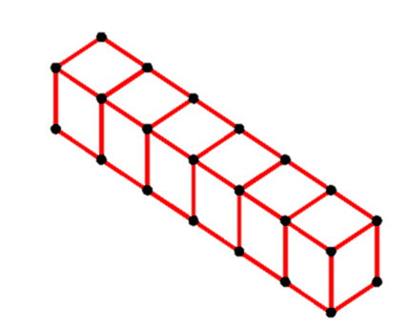
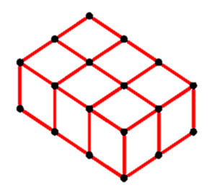
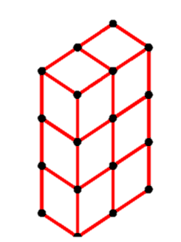
Candy Box Volumes

