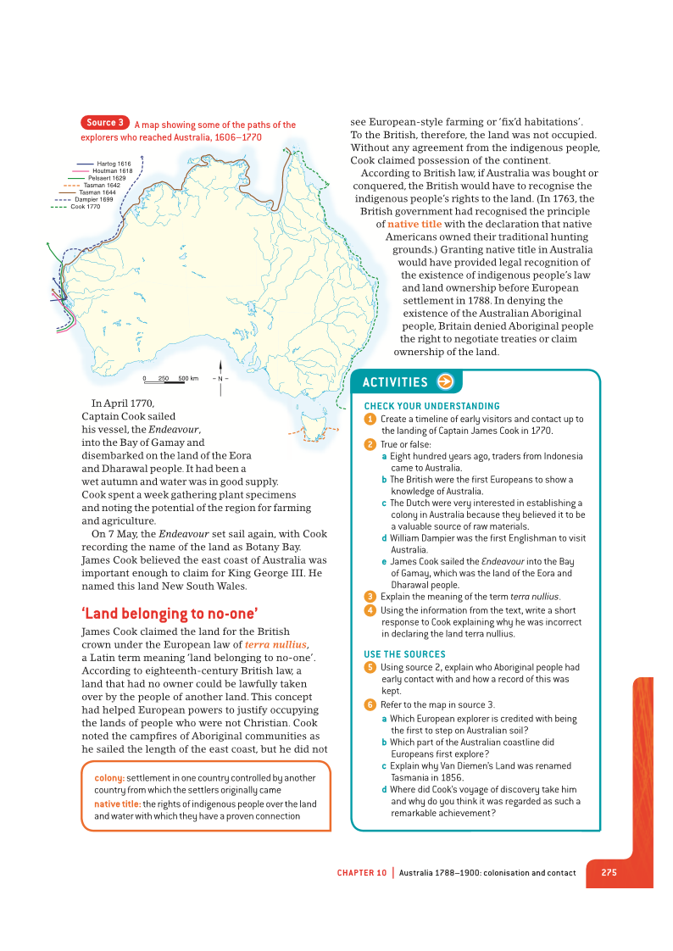 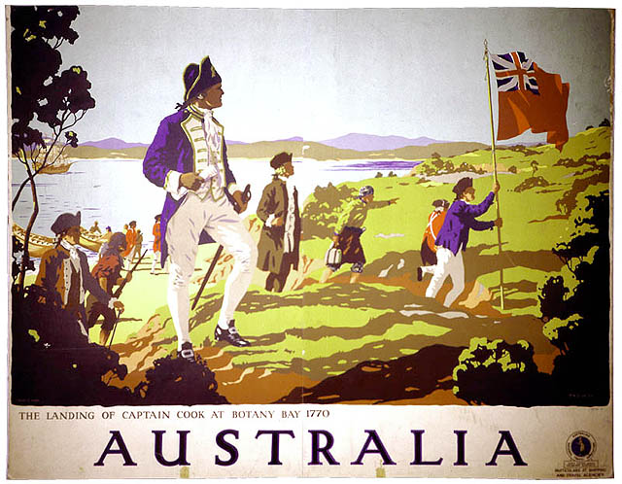

**Activities**

* Using the words or synonyms of the words from the Speed Dating Activity, write a 1 page letter to Captain Cook outlining why he illegally claimed Australia under the law of Terra Nullius and denied Aboriginals Native Title.

* Review the “Bloody Boat People” political cartoon below.

What is the author’s purpose of this image?

How does it reflect indigenous views of European settlement?

How does it challenge the traditional view of European Settlement shown in the Australian Day image?

